Northeastern State University



Banner Finance Training

SSB9 Budget Queries and Finance Screens

FOAPAL Elements
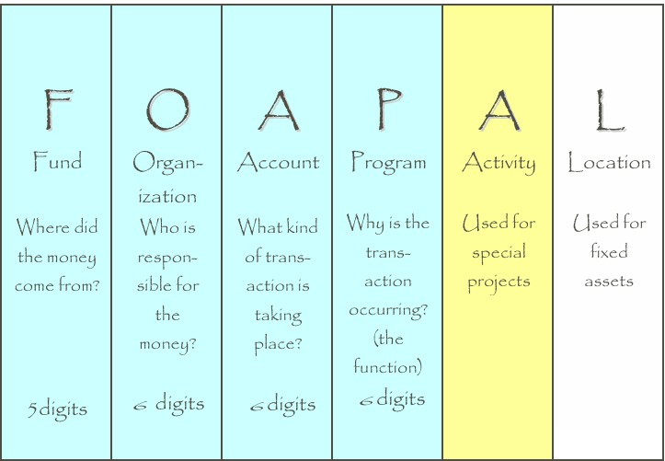

What does FOAPAL stand for?
FOAPAL is an acronym for fund, organization, account, program, activity and location. NSU primary uses FOAP for department spending. Activity and Location are used for capital projects and asset location.

Fund
- Identifies the source of the money (the “Where?”)
- Balance sheet and revenue/expense reports can be produced on a Fund
- Funds can be restricted (such as grants and endowments) or unrestricted (general)

Organization
- Identifies the unit responsible for managing the money (the “Who?”)
- May be associated or used with several funds ∙ Follows a structure very similar to our organization chart

Account
- Describes the “What?” of a financial transaction
- Identifies the kind of transaction taking place
- Examples:
479100 Sales Revenue -All deposits begin with a 4 account code 536140 Office Supplies-All payments begin with a 5 account code

Program
- Describes the function being supported by a transaction (the “Why?”) Program codes provide a way of classifying transactions across organizations and accounts
- Most educational institutions use program codes defined by the National Association of College and University Business Officers (NACUBO)
- Programs include:
  - Instruction
  - Research
  - Public Services
  - Academic Support
  - Student Services
  - Institutional Support
  - Operation and Maintenance of Plant
  - Auxiliaries

Activity
- Optional component of the FOAP(AL)
- Used to track revenue and expenditure activities within a project or program Location

Location
- Optional component of the FOAP(AL)
- Normally used to represent a physical location, such as a building or room

Accessing Financial Information

Finance Self-Service Banner (SSB) is a web browser-based tool that allows users to do many common tasks without having to log into the Banner System. Anyone with regular Banner 9 Finance rights has those same rights applied during a Self- Service session. This means they can only query accounts and documents or initiate budget adjustments for Orgs they have rights to in Banner 9 Finance. Likewise, they must be a Banner 9 Finance approver to be able to approve documents in Self-Service.

Logging into Self-Service
Self-Service Banner (SSB) is accessed through the goNSU site.
- Log into GONSU (Located in the top menu bar of www.nsuok.edu)
- Click the Finance Tab (located in the left menu bar)
- Choose SSB9 Finance Dashboard in the Banner Links box

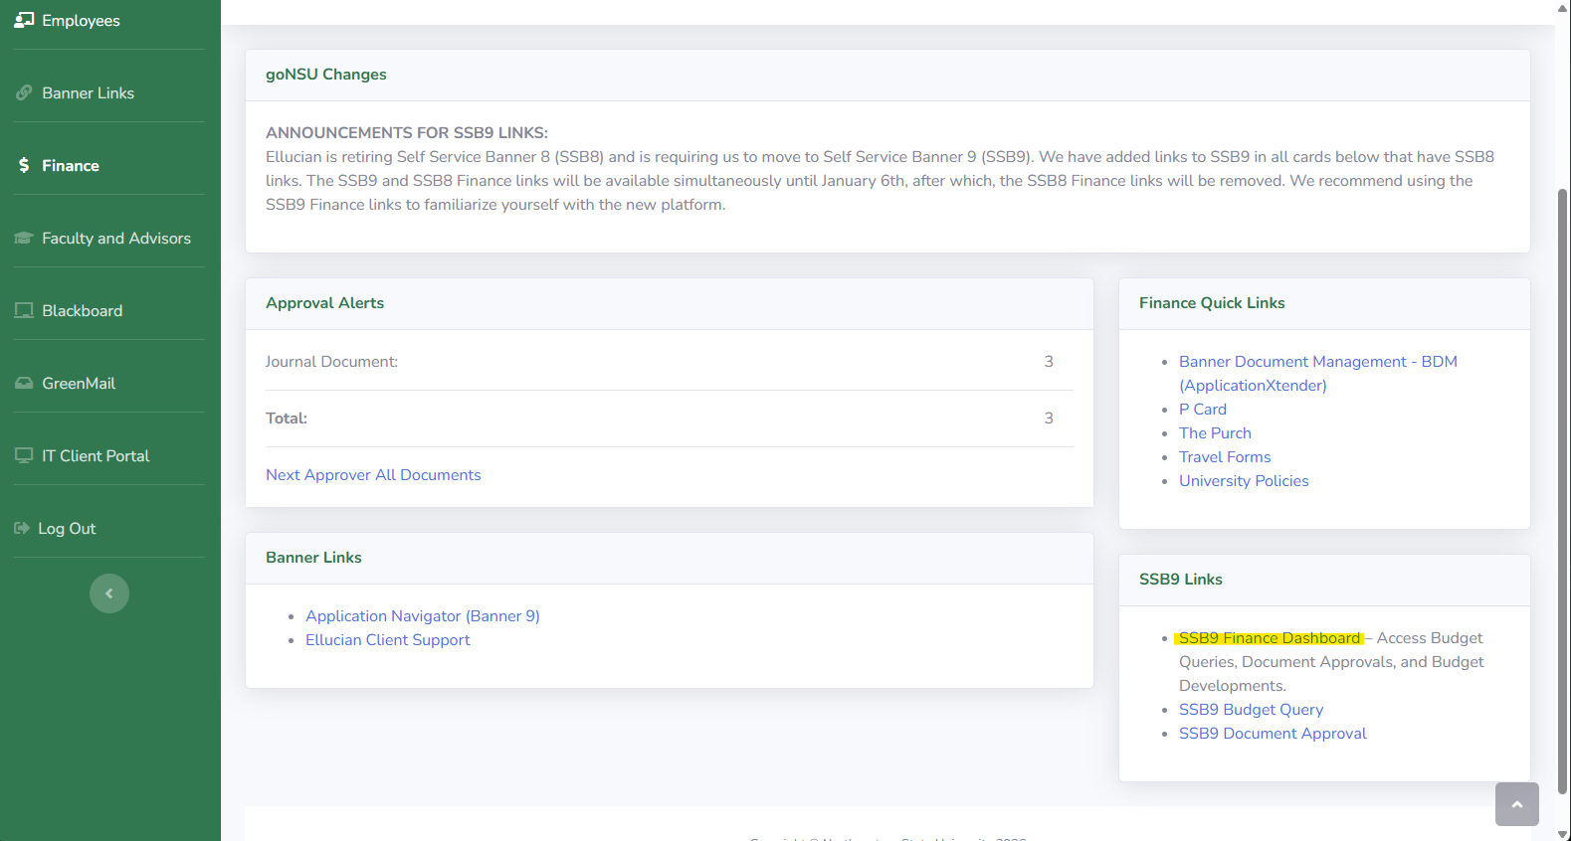
Any time a word, title, code or amount appears in a blue bold color it is a hyperlink that will bring the user to a new functionality or will drill down to some supporting documentation. As you work in Self-Service you can move backwards through your steps by clicking the left navigation arrow in the upper left of the screen.

If a Self-Service session is inactive, the session will expire for security reasons and you will have to log in again.
When you enter SSB 9 Finance, you will receive options to perform My Finance query, approve documents, delete finance templates, and view documents. The budget develop option shown in the screenshot below is only available to a limited number of individuals. This guide will be going through the My Finance Query option.
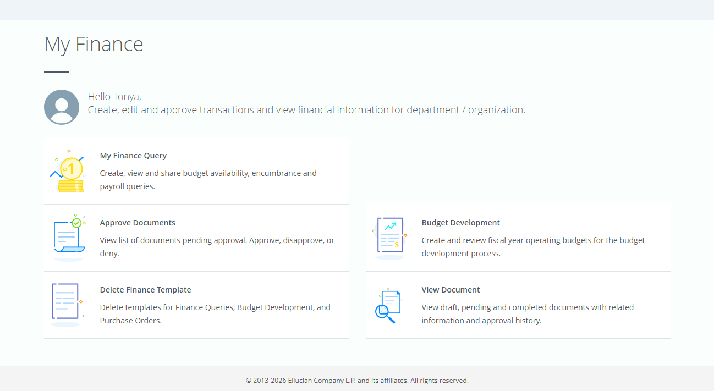

My Finance Query

Only POSTED transactions appear in finance queries. If a document is incomplete, or still in an approval queue, it is not posted and the amounts will not be reflected in Self- Service Banner.
To start a budget query, click on the My Finance Query option. The next screen will give you the query dashboard option to select any saved favorites queries or start a new query. The guide will provide more information about how to add favorites further into the steps. Let start by creating a query, select New Query in the top tight corner.
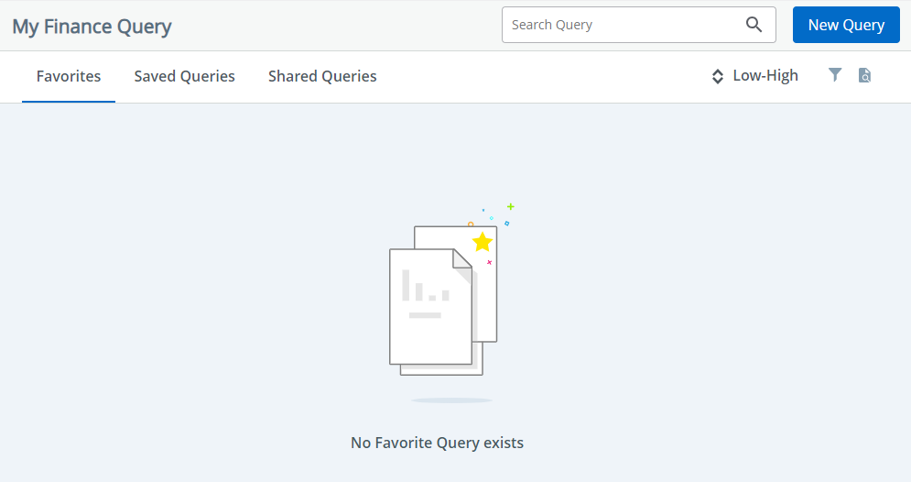

The query menu will pop up for you to select the query type and enter your FOAPAL and parameter settings. Below is a list of available queries. This guide will go over the Budget Status by Organizational Hierarchy that is recommended to view available budget.
Select Query Type contains the available query options:
Budget Status by Account-list all account codes in one screen where budgets, deposits and payments have been made to. This query does not group your account codes by budget type which can be helpful.
Budget by Organizational Hierarchy-This budget will group your transactions by budget type to provide a good view of where your available budget is currently showing.
Budget Quick Query- cannot drilldown to detail transactions or documents supporting the numbers reported–only returns four check-marked data elements below. The other two query types allow you to specify which of these ten available data elements to present in the report.
Multi Year Query- This query is used for multi-year budgeted FOAPs such as Grants and Capital projects that utilize a grant code. Other budgeted FOAPs will not be able to use this query option. This allows you to see the overall budget for a period of time rather than one fiscal year at a time.
The ten possible data elements for Budget Queries are:
- Adopted Budget – original budget entered or rolled from a prior year
- Budget Adjustments – budget changes
- Adjusted Budget – net of two above elements

- Temporary Budget – (we do not use this)
- Accounted Budget – Includes any budget changes in the past or future.
- Year to Date – actual transactions booked (JVs, invoices, direct pays, deposits, etc)
- Encumbrances – Generated by purchase orders and salary encumbrances; funds committed for future payments.
- Reservations – net open Requisitions
- Commitments –Equal to the total budget set aside for future obligations. These are made up of Reservations and Encumbrances.
- Available Balance – net available budget. Formula is: Adjusted Budget ,less Year to Date, less Commitments equals Available Balance.
Payroll Expense Detail-This provides employee payroll information. Financial Manager (Account Sponsor) must approve access to this query type. Grant code is not required.
Encumbrance Query- This query allows you to look at the active purchase orders set up in a FOAP.

Budget Status by Organizational Hierarchy

Once the Create New Query menu pops up, select the drop-down menu for Select Query Type and choose
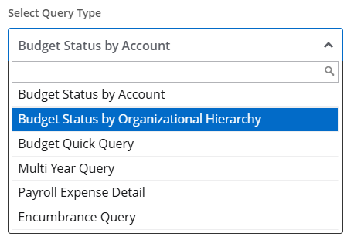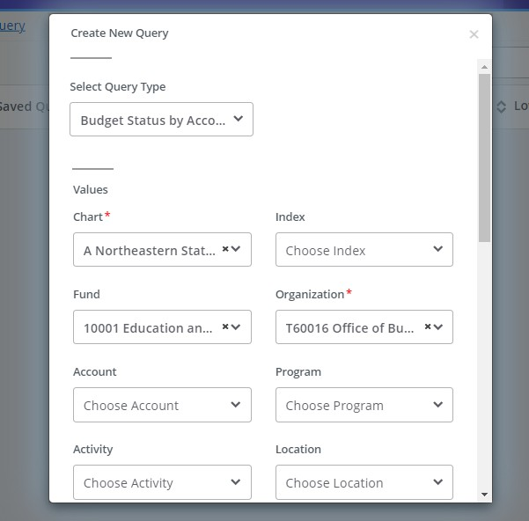
Fill in the values for your query.
Chart: A Northeastern State University- This will not change.
Index: Leave blank
Fund: The funding source you want to view
Organization: The organization for your funding type
Account: Leave blank (if you know the specific account code, then you can enter the code but it will not provide you with your overall available balance)
Program: Leave blank (If you query by program code, you may not capture transactions that were coded improperly)

Activity: Leave blank (You can enter a code if you utilize this feature, such as capital projects)
Location: Leave blank
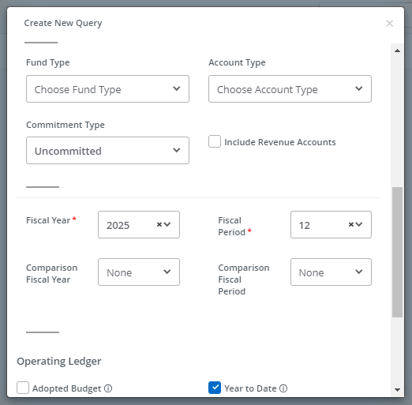

When you scroll down in the query menu, you will notice all the value options are located in one area.

Fund Type: Leave blank
Account Type: Leave blank
Fiscal Year: Enter the fiscal year you want to view
Fiscal Period: Enter the period you want to query. It is recommended you enter 14 to capture all data.
Comparison Fiscal Year: Leave blank Comparison Fiscal Period: Leave blank Include Revenue Accounts: Unchecked
Revenue query is mentioned further into this guide.

Note: You can query using a specific “Fund Type” or “Account Type” by populating those fields. Common Fund Type queries would be:
- 11 Current Unrestricted Funds
- 21 Grants
- 31 Auxiliaries
- 91 Plant
Common Account Types used would be:
- 5A-5D for Salaries and Wages
- 5E for Benefits
- 51 Professional Services

- 52 for Travel
- 53 for Operating Expenditures (O&M)
- 54 Equipment

Fiscal Period-is monthly. i.e. 03 is September, 04 is October, 05 is November and 14 is the Accrual Period which includes all the final entries for the fiscal year. The query results will always be cumulative year-to date through the end of the fiscal period specified. Using period 14 will always give you the cumulative up to-date total for a fiscal year.
Comparison – Fiscal Year/Period-dropdowns allow you to see comparable data for two fiscal years in the query results. The comparison fiscal period does not have to be the same as the primary fiscal period. For example, you may want to see the current year as of period 04, but the prior year as of period 14.
Commitment Type-relates to budgeted values and the query options are Uncommitted, 10 Committed or Both. All normal budget transactions are Uncommitted – meaning the budget can be used by any type of transaction charged to that FOAP string. When purchase orders are rolled from one fiscal year to another the related budget is also rolled – but as Committed. This means that rolled budget can only be used by that purchase order and invoices tied to it.
The Office of Budgets and Accounting advises to pull budgets without an account code, program code and/or account type added. This will allow you to pull the budget that The Purch is budget checking against.

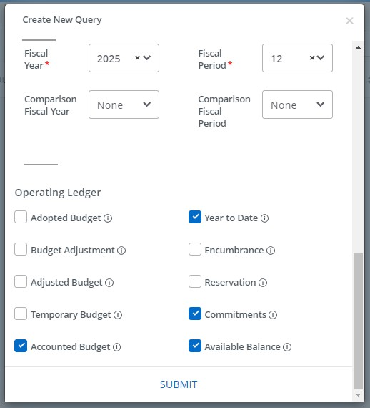

The last section of the query menu requires the operating ledger columns you would like to view. The items selected in the screenshot below are The Office of Budgets and Accountings recommendations (Accounted Budget, Year to Date, Commitments and Available Balance). You can select more or less for the information you require.
The additional operating check boxes available are adopted budget, budget adjustment, adjusted budget, temporary budget, encumbrance and reservation.

Before diving into the query, SSB9 has new query options located to the right under New Query. Starting from the left the icons are edit query (pencil icon), share query (share icon), save query (floppy disc icon), view parameters (information icon) and view more (kebab icon). Below are screenshots of the view query parameters and view more options.
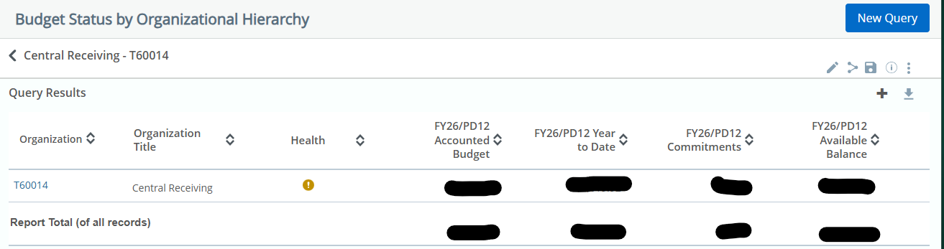

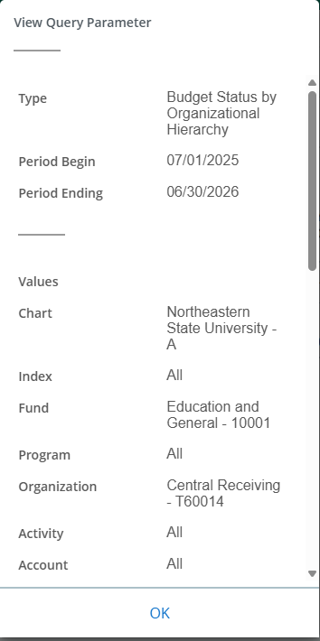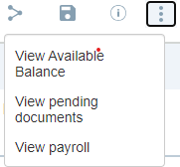

Within the view more menu: (Kebab menu or the vertical 3 dots) View Available Balance, View Pending Documents, View payroll (accesses has to be requested and approved by account sponsor). To utilize view available balance, an account code must be included in your budget query.

To utilize view available balance, an account code must be included in your budget query. Budget are split between compensation and nonsalary budgets. The 6X budget (nonalary) shown below is the amount The Purch will budget check against.

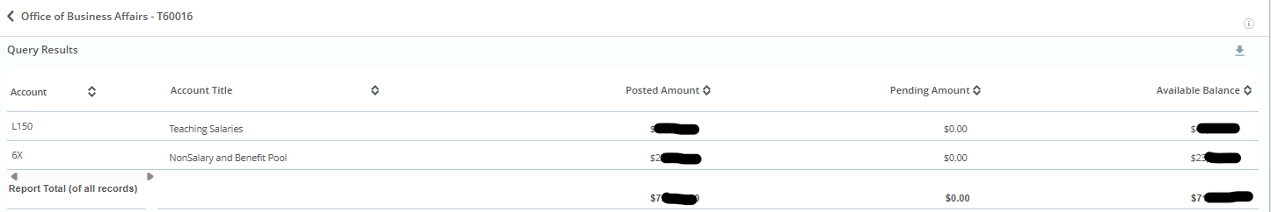

Go back to the main menu of the query by selecting the arrow next to your department name. Click on your organization code that first appears in your query. The budget data will be split
between compensation and operating expenses. You will select the blue number 6 or 7 to dive deeper into the budget data.

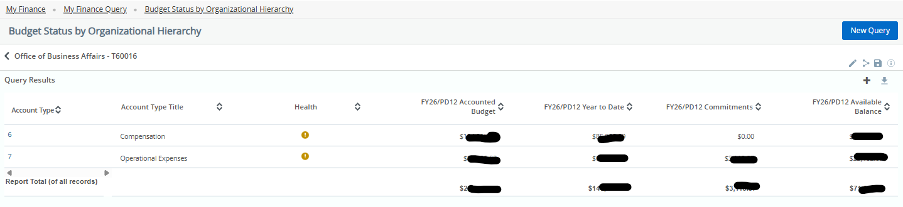

By selecting 7, the query will provide more detail on where the operating expenses budget is established.

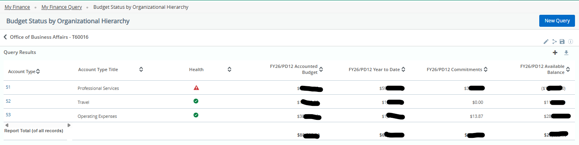
You may have also noticed the icons appearing in the health column. This is a new feature of SSB9 to show you the health of your budget. Since NSU budgets at the high level (L account codes) you may see several red triangle explanation icons when drilling down into your budget but the overall operating expenses have a green circle check mark indicating good health.
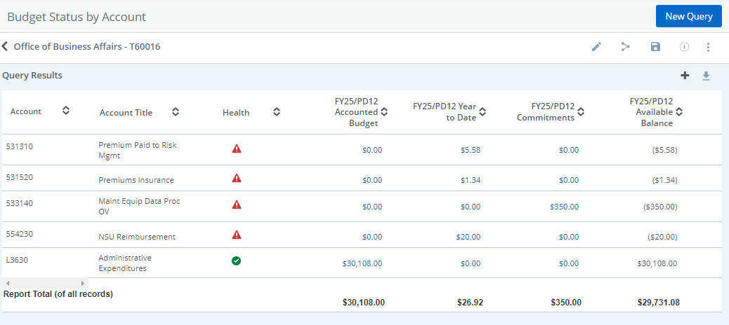
To view more information on the year-to-date payments or commitments select the blue hyperlink amounts. Transactions will appear that make up the amount you just selected.
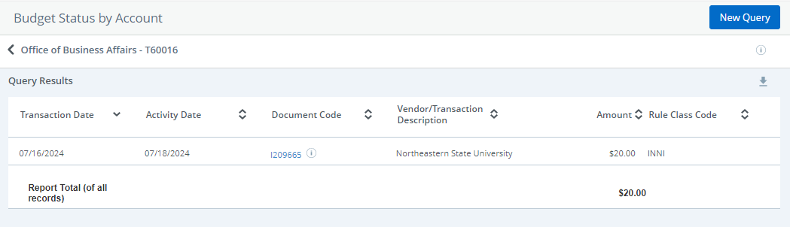

When you are at the transaction code level, you can click on the document code that will bring up a pdf file with the expense description and other information. You can select the circle i icon to view related documents, such as check number. This is the Banner check number and not the number printed on the check from the State of Oklahoma.

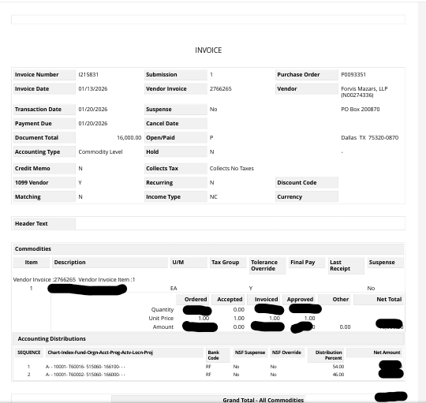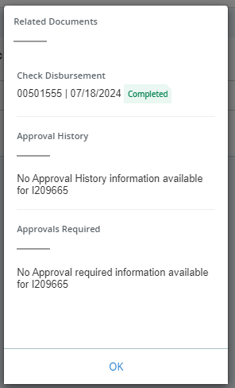

Go back two menu screens where you see the accounts types as 51,52,53, etc. To save a budget query, you must be within the Account Type of Compensation or Operating Expenses. Note: when budget queries are saved, you are not able to go back (from account type 52,53,54 to account type 7) to view other data.
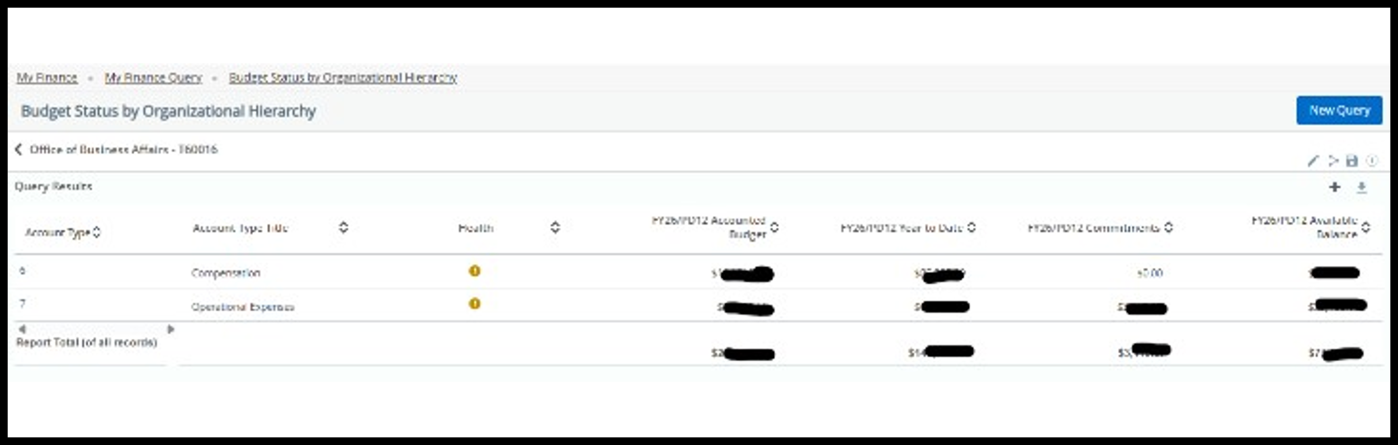

Select the Save icon, enter a query name, click the set as favorite and then select save.

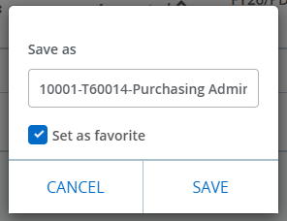
Your budget will now appear in Favorites on your My Finance Query dashboard. SSB9 also provides a visual chart so you can see your budget amount at a glance along with the date of the budget query located in the bottom left corner. For this example, the budget health chart does not include the compensation budget since the query was saved with only the 7 account type budgets, operational expenses.
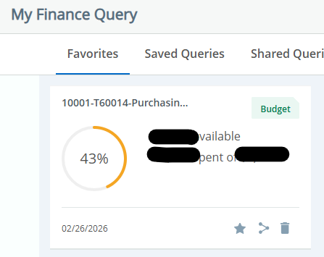
If you have multiple operating FOAPs, you can create a saved query for each one for quick budget searches.
The dashboard also allows you to save other queries such as the encumbrance query. The parameters will be the same as above but your will choose encumbrance query instead.

Encumbrance Query Values

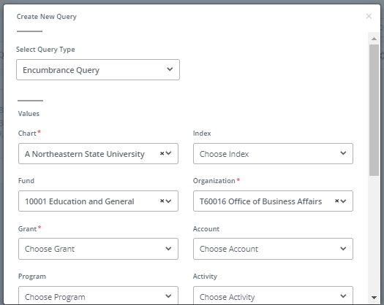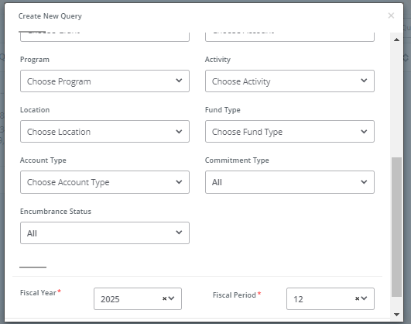
In the above screenshots, you will notice that only the following values are filled; Chart, Fund, and Organization in the encumbrance query. Encumbrance query does not require a grant code even though an asterisk is next to the title. Select commitment type of all, committed or uncommitted. Select encumbrance status of all, open or closed.
Once you select submit at the bottom of the create new query, your query will provide your open and or closed encumbrances. To see invoices associated with the purchase order, select the document code number.
SSB9 now allows you to delete queries you no longer need. See the trash can icon in the bottom right-hand corner of each saved query on the My Finance Query home screen.
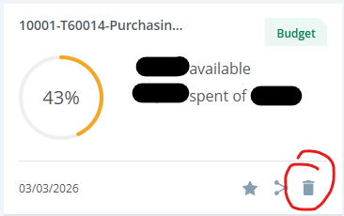

Budget Status by Account

Revenue Query
To start a revenue query, click on the My Finance Query option. The next screen will give you the query dashboard option to select any saved favorites queries or start a new query. The guide will provide more information about how to add favorites further into the steps. Let start by creating a query, select New Query.
The query menu will pop up for you to select the query type and enter your FOAPAL and parameter settings. Below is a list of available queries. This guide will go over the Budget Status by Account that is recommended to view revenue Profit (Loss) report.

Once the Create New Query menu pops up, select the drop-down menu for Select Query Type and choose
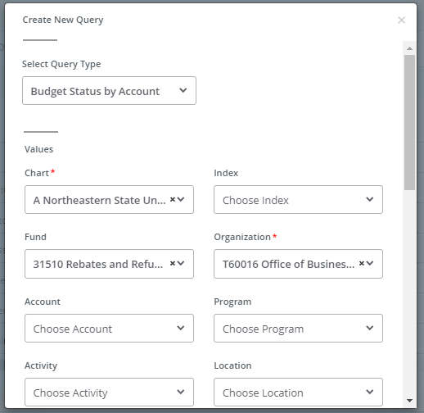
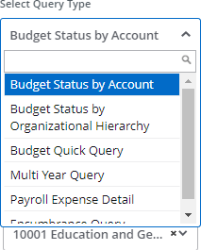

Fill in the values for your query.
Chart: A Northeastern State University- This will not change.
Index: Leave blank
Fund: The funding source you want to view
Organization: The organization for your funding type
Account: Leave blank (if you know the specific account code, then you can enter the code but it will not provide you with your overall available balance)

Program: Leave blank (If you query by program code, you may not capture transactions that were coded improperly)
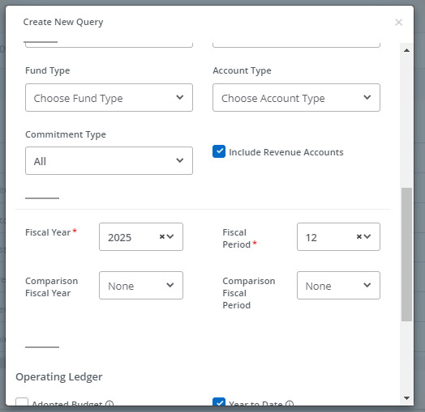
When you scroll down in the query menu, you will notice all the value options are located in one area.

Fund Type: Leave blank
Account Type: Leave blank
Fiscal Year: Enter the fiscal year you want to view
Fiscal Period: Enter the period you want to query. It is recommended you enter 14 to capture all data.
Comparison Fiscal Year: Leave blank Comparison Fiscal Period: Leave blank Include Revenue Accounts: Checked

For operating ledger options, select the accounted budget, year to date, commitments and available
balance check boxes.

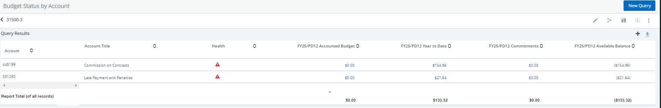

By clicking on the blue number amounts under Year to Date. You will be able to see the transaction amounts in each account code. Account codes beginning with a 4 is revenue and 5 account codes are expenses.
You may have also noticed the icons appearing in the health column. This is a new feature of SSB9 to show you if you collected or spent funds when compared to the budget amount. Since NSU budgets at the high level (L account codes) you may see several red exclamation icons next to each account code. To compare your revenue budget against collected amounts, create a Budget Query by Hierarchy and check the ‘include revenue amounts’. This query type will group your revenue amounts for better comparison to a budget total.
To save a budget query, click the Save icon, enter a query name, click the set as favorite and then select save. Your saved query will now appear as a bar chart to show your profit(loss) in the query you created.

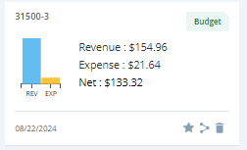

Banner 9-Application Navigator

Banner Inquiry Screens

Below is a list of the most commonly used Banner Finance Inquiry Screens in Application Navigator. Included with each screen is an explanation of the information it displays as well as instructions on how to use it.

- FGIBDST – Organization Budget Status

- FGITBAL – Trial Balance

- FGITRND – Transaction Detail Activity

#1 FGIBDST

Finance General Ledger Inquiry Form Organizational Budget Status
This screen displays budget, YTD activity, commitments and budget availability for a specified FOAP(AL) sorted by account code.
- At the Dashboard, type “FGIBDST” in the Search . . . Field and press enter.
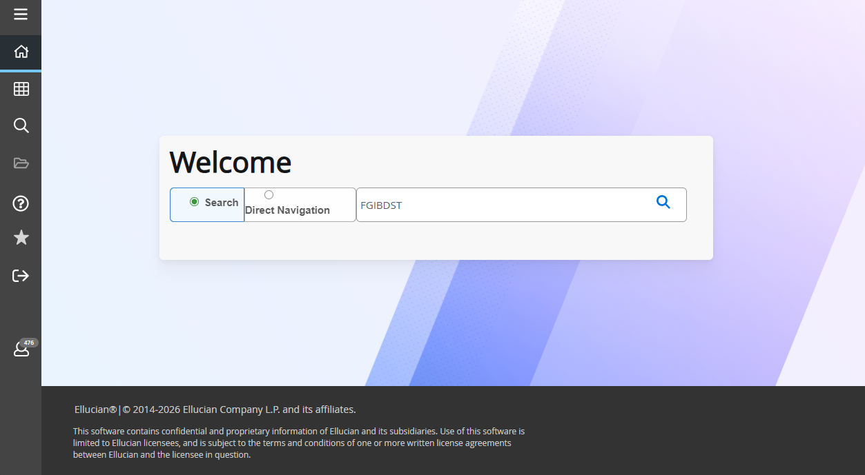

- This will bring up a screen that looks like the following:
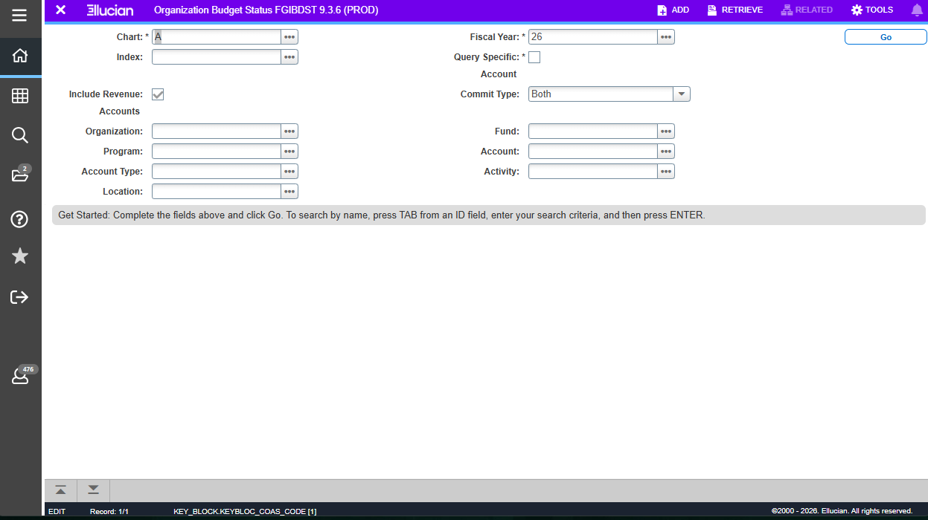
- The Chart field defaults to A.
- The Fiscal Year field defaults to the current fiscal year.
- The Index field is not used at this time.
- For State Appropriated Funds (10001), click Include Revenue Accounts to remove the check. Removing the check allows the available balance to be seen in funds where there is no revenue. If using a fund with revenue, this step is not necessary.
- In Commit Type field, Uncommitted should be selected. Committed options includes the budgets that rolled over from the previous fiscal year.
- In the Organization field, type in your organization number.
- In the Fund field, type in your Fund number.
- Type in Program field (optional). The program code could produce an incorrect budget report if expenses and/or revenue was entered with a different program code than the one used for the query.
- In the Account field, leave blank to display all accounts (recommended) or type in an Account number to display that account and all successive accounts.
- 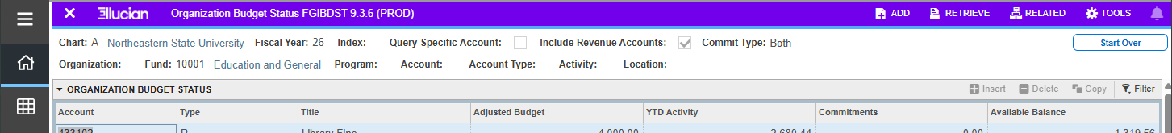Click GO. You will see the adjusted budget, YTD activity, commitments and available balances for any accounts codes that have been used.

- To view more data, you can choose the related menu option at the top of the screen. In the menu you will find:
  - FGIBSUM – Organizational Budget Summary (for specified Fund and Organization)
  - FGIOENC – Organizational Encumbrances List (for specified Fund and Organization)
  - FGITRND – Default Transaction Activity (for selected Account)
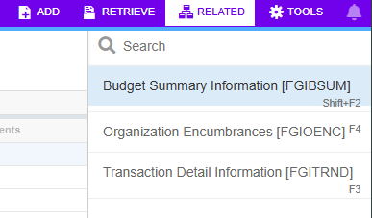

#2 FGITBAL

Finance General Ledger Inquiry Form

Trial Balance
This screen displays the current account balances for a Fund.
- At the General Menu, type “FGITBAL” in Search . . . field and press enter or tab.
- The Chart field defaults to A.
- The Fiscal Year field defaults to the current fiscal year.
- In the Fund field, type in your Fund number.
- In the Account field, enter 101999 to display the Claim on Cash. This is the available cash the department has to spend.
- Click Go. The current balance for each Account is displayed. The Debit/ Credit field indicates whether the balance is a debit or a credit. An asterisk after the Debit/Credit field indicates if the balance is opposite of Normal Balance.

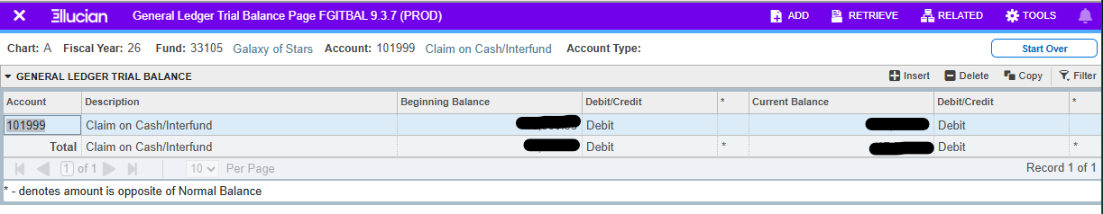

#3 FGITRND

Finance General Ledger Inquiry Form

Transaction Detail Activity
This screen displays detailed transaction activity for specified FOAP(AL) elements sorted by account.

    - At the General Menu, type “FGITRND” in Search. . . field and press enter or tab.
    - The Chart field defaults to A.
    - The Fiscal Year field defaults to the current fiscal year.
    - Enter one or more elements of the FOAP(AL) you wish to view.
    - Click Go
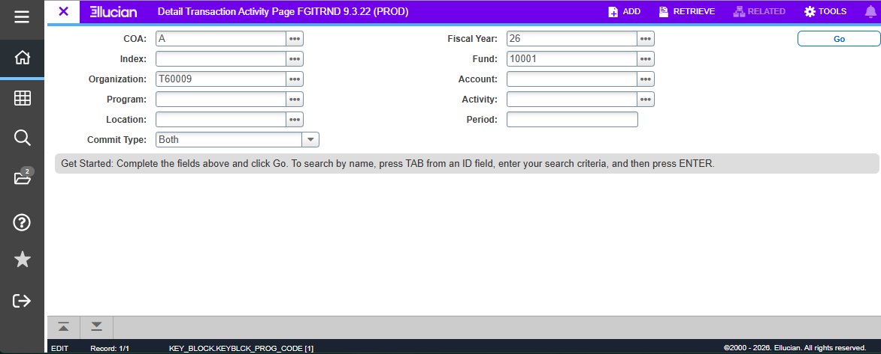

    - A filter screen will appear. To limit the amount of data being returned in the query, include a search parameter.
      - All year-to-date transactions related to the FOAP(AL) are displayed. The Type column
indicates the transaction type for each document.
      - The Field column indicates the category (Budget, Year-to-Date, Requisitions and
Encumbrances) the expenses post to.
OBD & ABD= Original and Adjusted Budget YTD=Year-to-Date, paid transactions RSV=Requisitions
ENC=Encumbrance

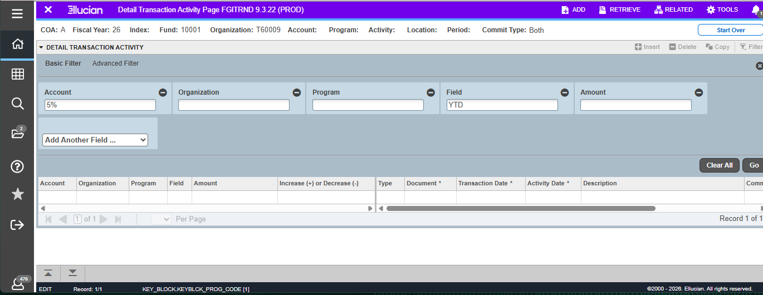
    - Click Go in filter menu to run query . The total for the transactions returned for your query is listed at the bottom of the screen.
    - To view other information for each transaction such as document number and document description, click on the arrow on the horizontal scroll bar located near the bottom of the form.

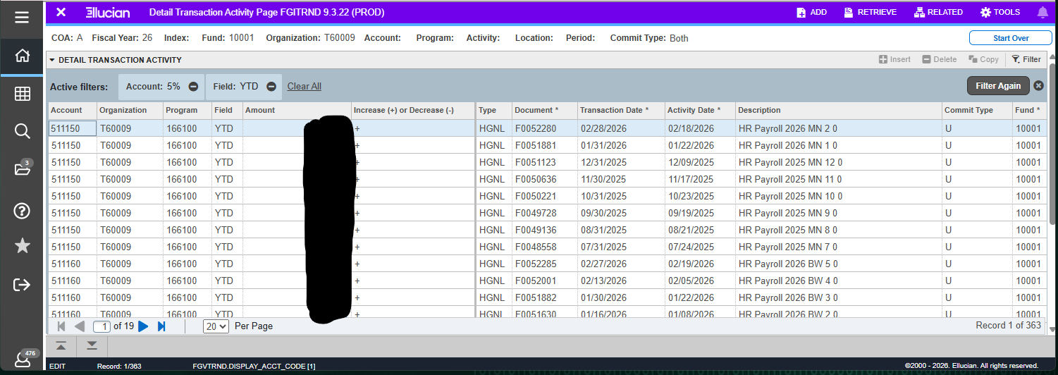

- Related screens available in Banner Related menu:
  - Query Document (By Type)
  - Detail Encumbrance Info (FGIENCD)

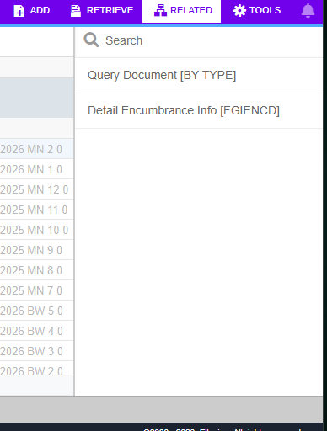

Exporting to Excel

Exporting data from Banner into an Excel document can be a very useful technique to organize data so that it can be manipulated. It also allows one to save data to the hard drive for easy access.

The instructions following use the example of the FGITRND form, but any data from a Banner inquiry can be exported to Excel using the same steps.
- Once you have populated the data block with the information you need, click on the Tools
menu, and choose Export.
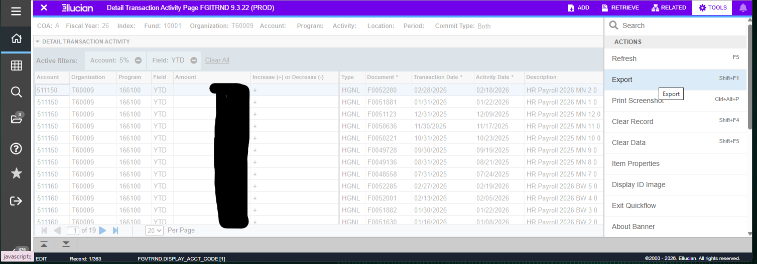

- The file will automatically download to your computer
- Open the file from your download folder on your computer. At this point, you can adjust the columns, add titles and headings, add formulas, and format the document however best suits your needs.

Glossary of Banner Terms
This section is a glossary of terms that will help you use and understand the Banner system.
Account – The 6-digit number that specifies the kind of transaction taking place. Used for both revenue and expense transactions.
Banner – Software system that processes, retrieves, and reports information as an integrated database. Banner integrates student, financial, human resources and financial aid information.
Block – Banner forms, or screens, are broken into blocks.
Chart of Accounts – A list of the fund, organization and account numbers, and program and activity codes. In general, a chart of accounts provides a structure for capturing financial data and reporting information about financial activity.
Commitment – Equivalent to Encumbrance (see below)
Document ID – A sequential identification code, consisting of letters and numbers that are assigned to a transaction when it is processed in the Banner system. Examples of document ID’s: J00xxxxx – Journal Entry; P000xxxx – Purchase Order; I00xxxxxx– Invoice Number; R00xxxxx– Requisition Number.
Encumbrance – The estimated amount of a purchase order, contract, or salary posted against an account(s). An encumbrance is established when goods or services are ordered. Encumbrances are cleared as payment for the goods or services is made.
Expenditure – Charges incurred for operation, maintenance, interest, and other expenses during the current fiscal period.
FOAP(AL) – Acronym for F und, Organization, Account, Program, Activity, Location. Fund – The 6-digit number that specifies the source of the money.
goNSU – The online access point (web portal) to NSU’s Banner system.
Module – A component of the Banner system providing specific information. The Finance module provides detailed financial information; the Student module provides information on student schedules, grades, etc. Object – Banner form, report, process, or table.
Organization – The 6-digit number that specifies the unit responsible for managing the money.
Program – The number that identifies the function being supported by the transaction. Based on the standardized categories of expenses as defined by NACUBO (National Association of College and University Business Officers.)
Query – A method of requesting specific information or a way to narrow a search for information.
Transaction Type – Banner rule code that is used to classify documents by type.

