The Purch – Blanket Order Manual

1. Select Blanket Orders Form on Dashboard
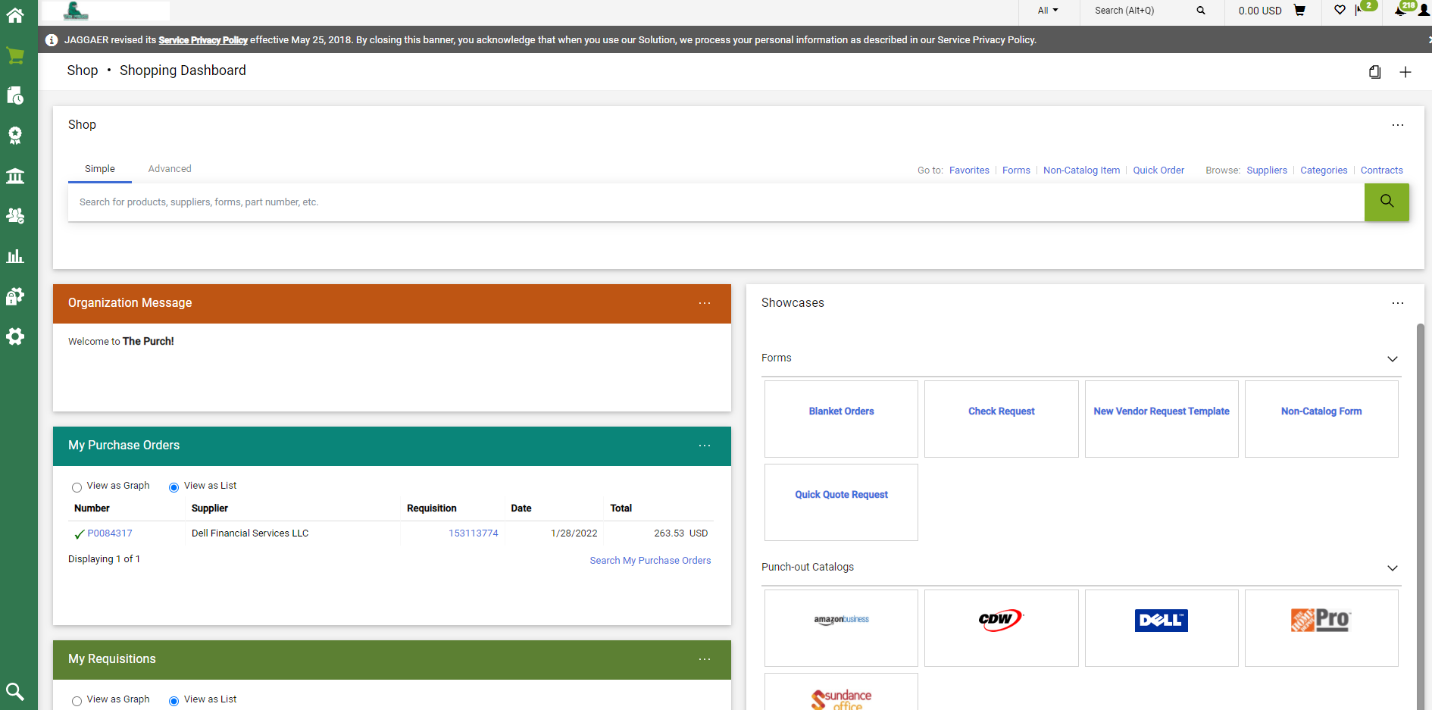
- Start typing in the Supplier Information Box, then select the correct name from the auto populated names.
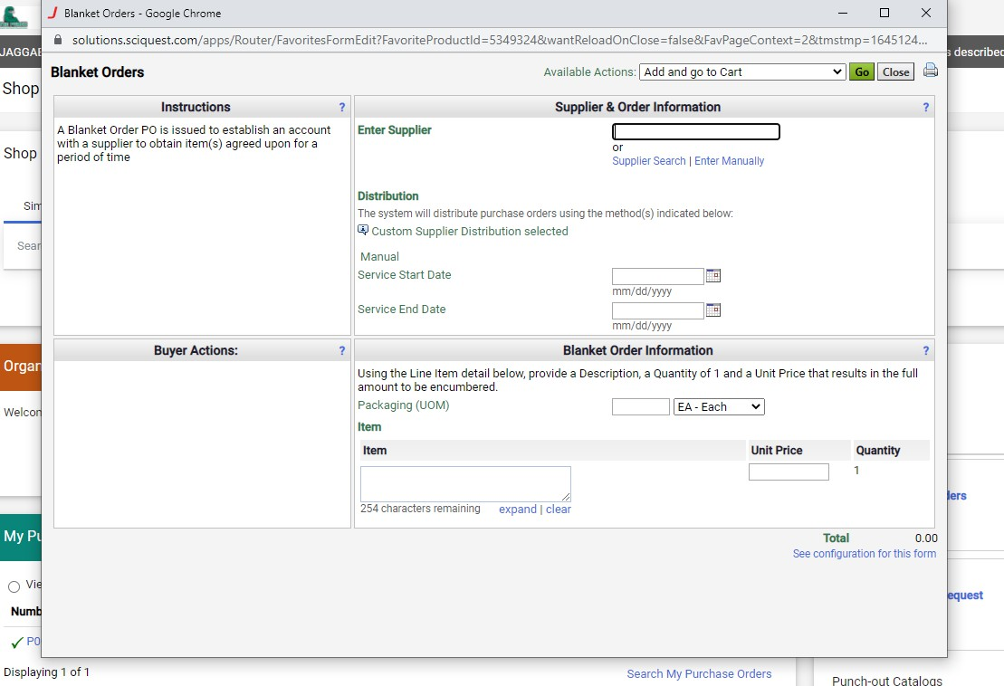
- The supplier information and address will appear at the top of the screen.
- If you need to select a different address, click on “Select Different Fulfilment Center”, then select the correct address.
- In the “Distribution Section”, select the Service Start Date and Service End Date by using the calendar.
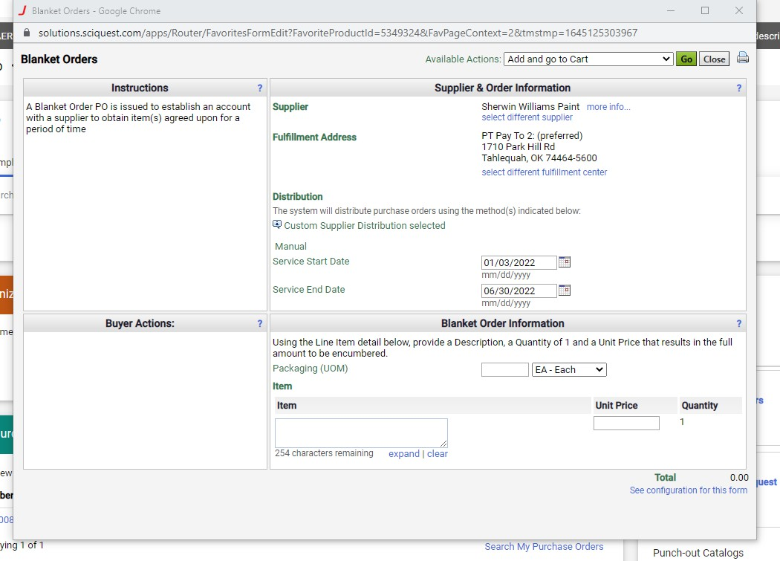
- Type in the description and the unit price/amount of PO total. In the “Blanket Order Information” Section
- If needing to add additional line, click drop down box in the “Available Actions” section and select “Add to Cart” and click “Go”, then fill out the “Blanket Order Information” section for new item.
- Click drop down box in the “Available Actions” and select “Add and go to Cart”
- Click “Go”
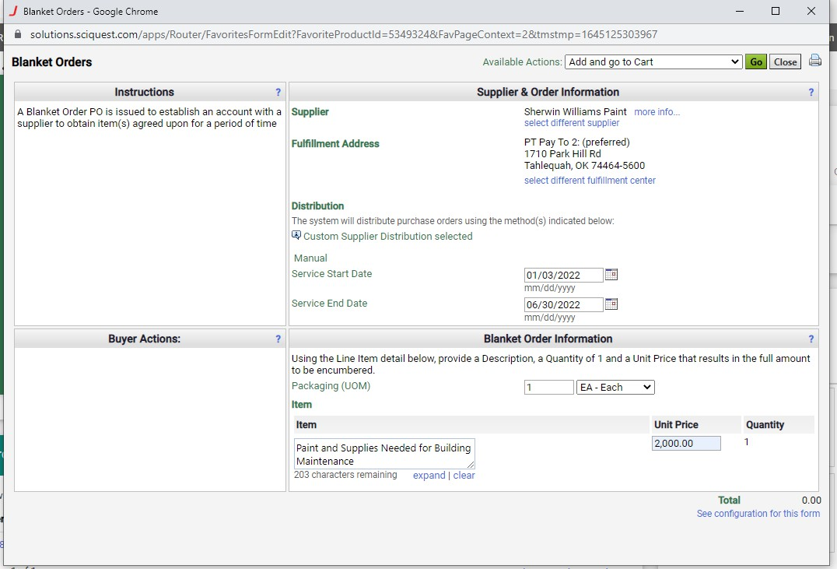
- Review information and click “Proceed to Checkout”

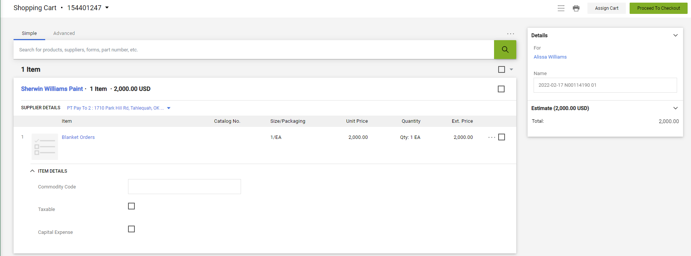

- Click on the pencil icon to edit the shipping address.
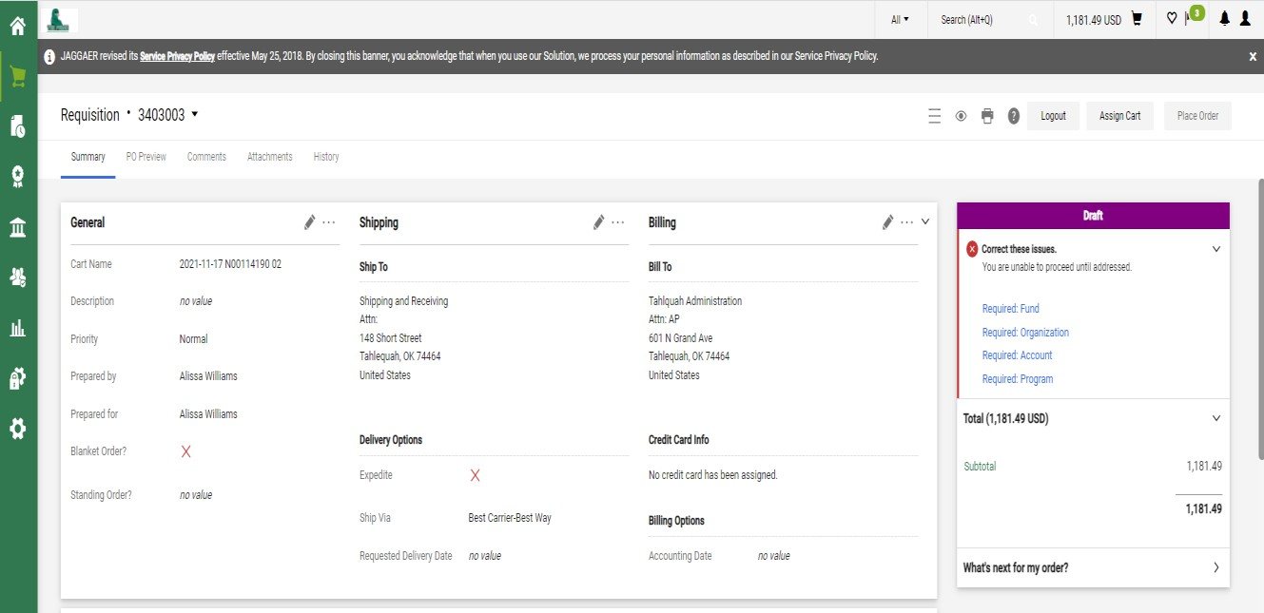
- Select the shipping address and enter your name and/or department in the Attn field.
- Click Save.
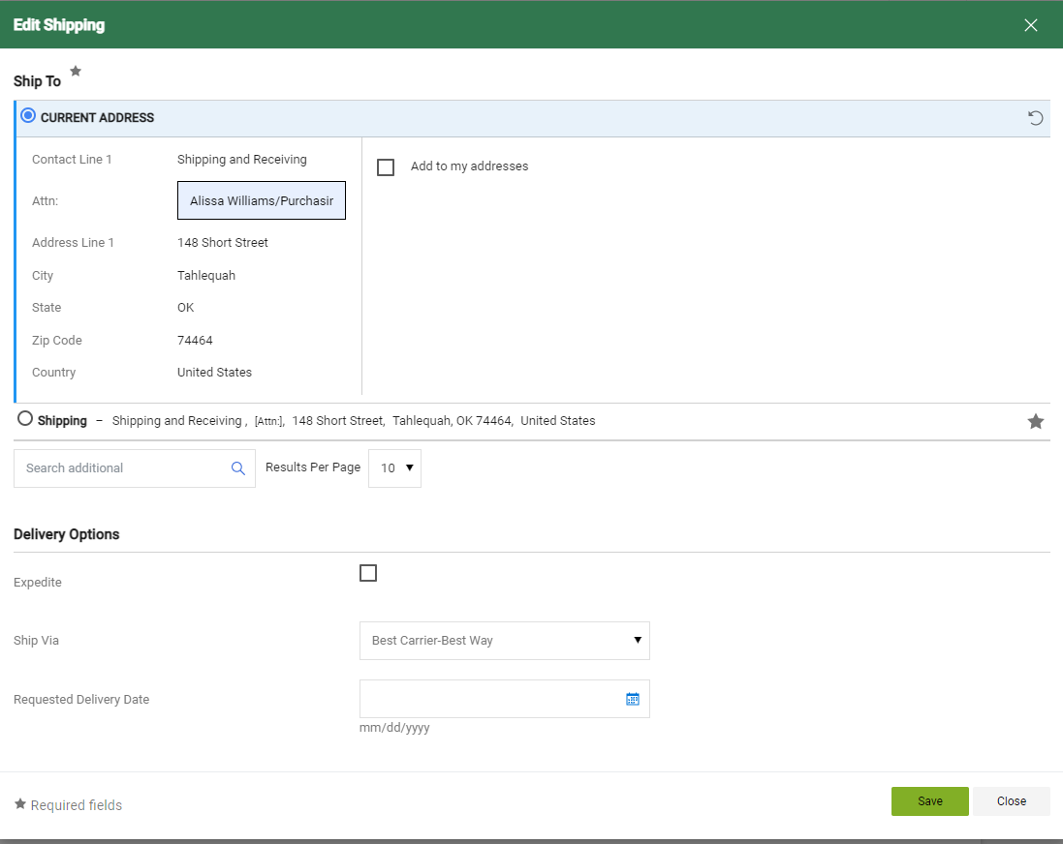

- Click in the pencil icon in the Accounting Code section to enter FOAP information.
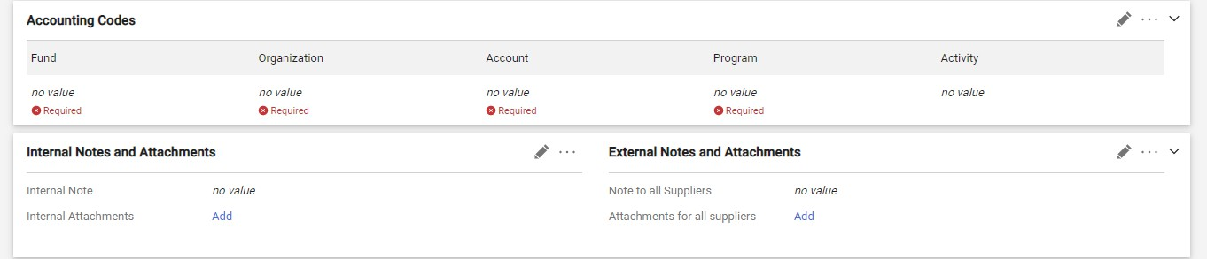
- Type in the Fund, Org, Account, and Program Codes
- Click Save
(*If one or more items have a different account code or need to be coded to a different FOAP, go to next step.) 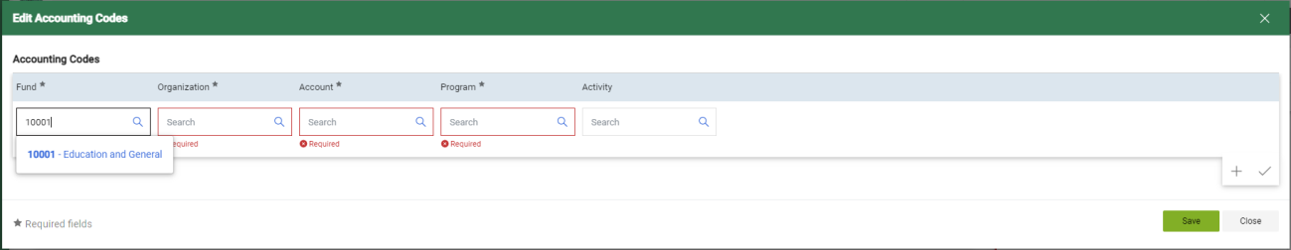

- If another line item has a different FOAP or Account Code, Click the ellipsis on the right side of the line item you are needing to change the FOAP or Account Code.
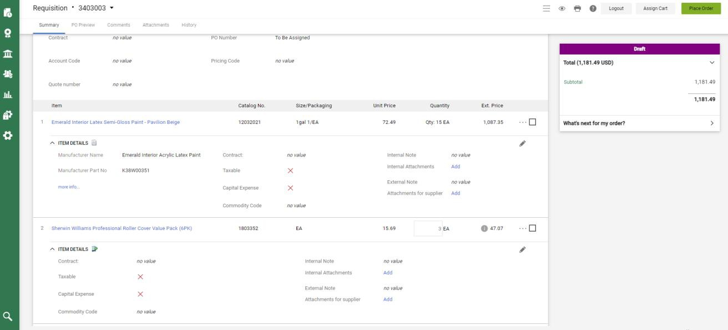
- Click “Accounting Codes”
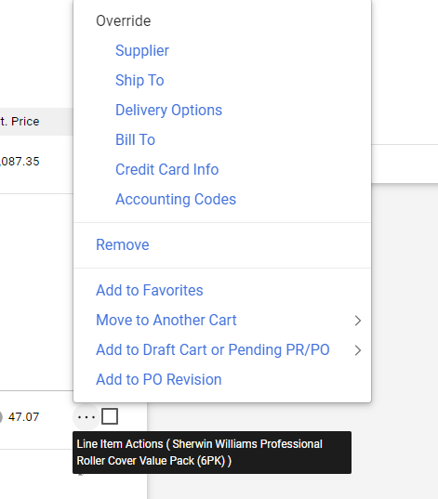

- Enter the correct codes that need to be changed
- Click Save
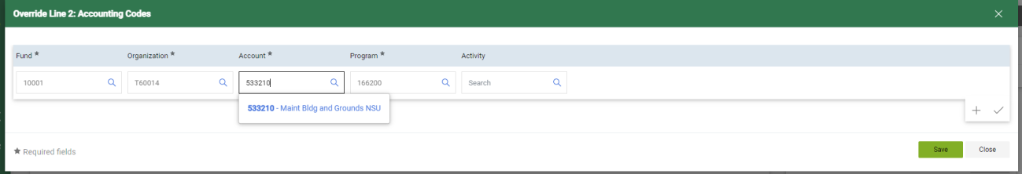
- Add Backup Documentation (Quote, Agreement, Food Form, etc.,) by clicking “Attachments” 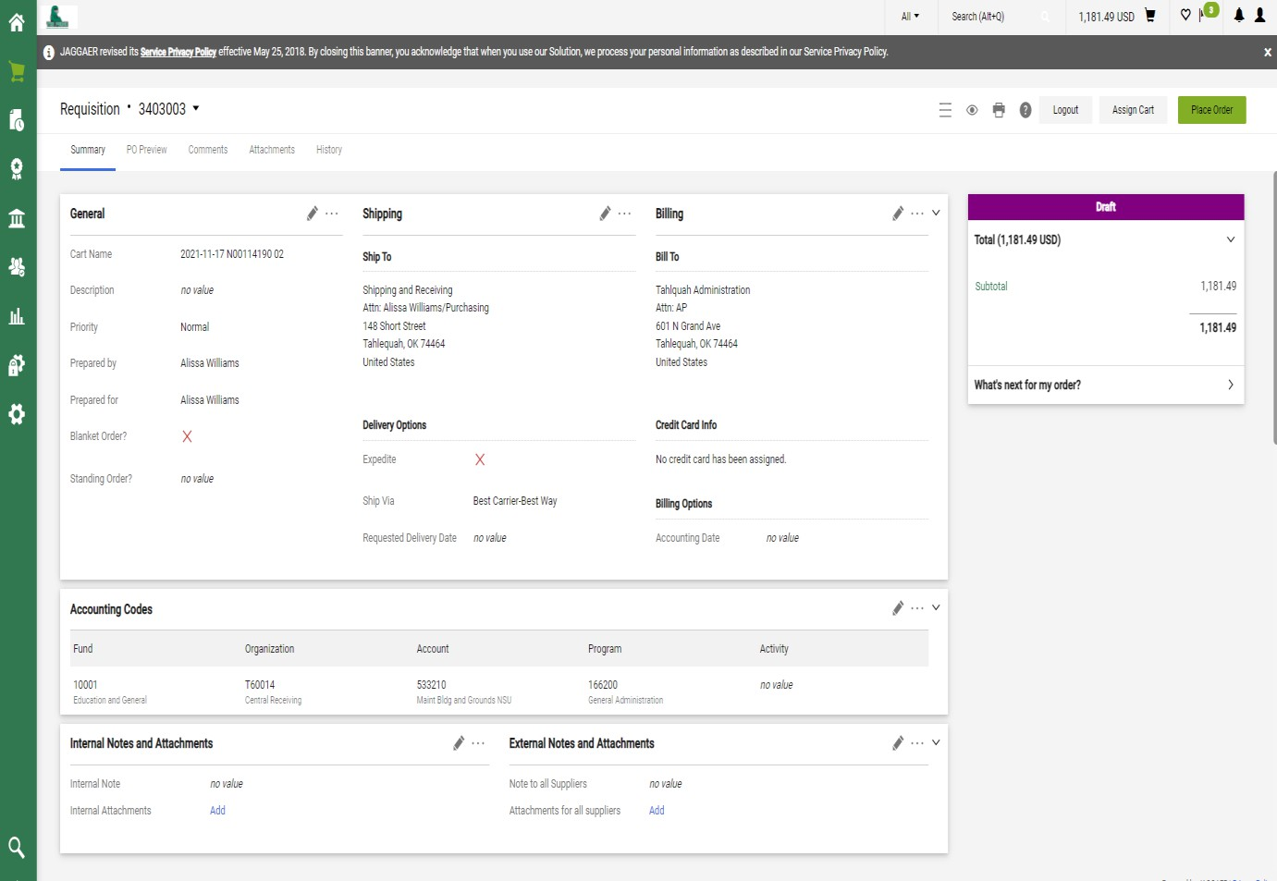

- Click Add Internal Attachment
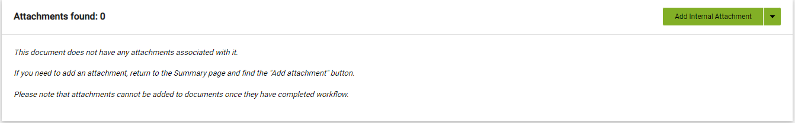

- Click “Select Files” and then choose your file to attached.
- Once file is attached, click on “Save Changes”
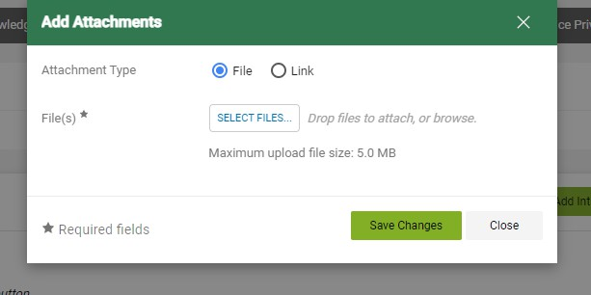

- Click “Place Order”, if no other changes need to be made.


- The Requisition is now completed and submitted for approvals.
