Receiving in The Purch

***Receiving is to be done after the PO has been completed and after the goods or services have been received on campus. By completing the receiving you are authorizing Accounts Payable to issue a check.
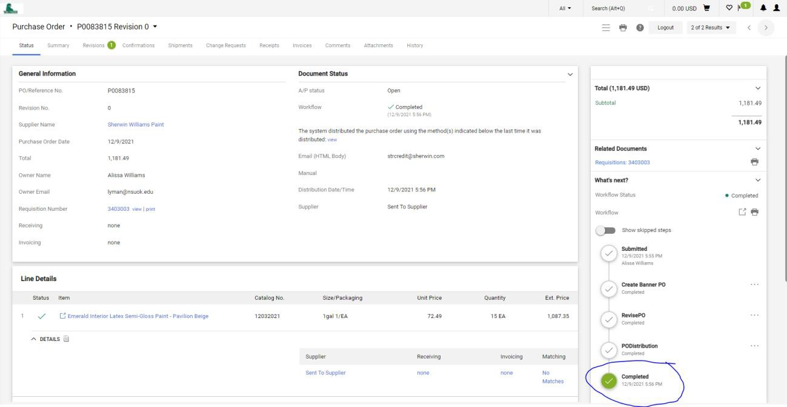

- After locating and selecting the purchase order, select the Receipts tab. (There may or may not already be Records Found depending on the PO).
- Click the plus mark on the right side of the page to begin a new receiving document.
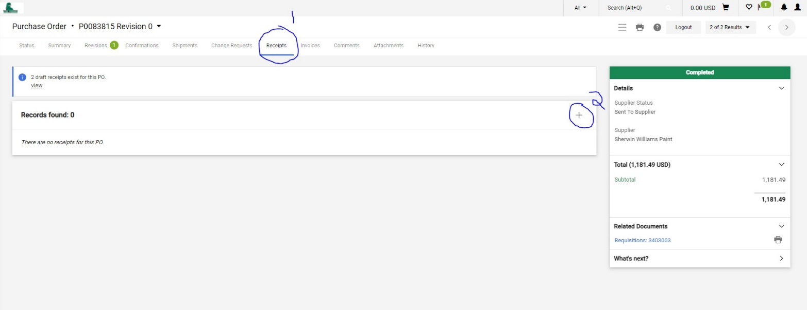

- Once in the Quantity Receipt page fill out as much information as possible.
Receipt Name: Auto populates with the date and Vendor Number. This can be left alone or changed.
Receipt Date: This should reflect the date that the items were received or services rendered.
Packing Slip, No: If applicable can be entered here.
Carrier: Select the carrier from the drop-down menu or select “Other”.
Tracking No: If applicable can be entered here. Attachments: If applicable can be uploaded here. Notes: If needed can be entered here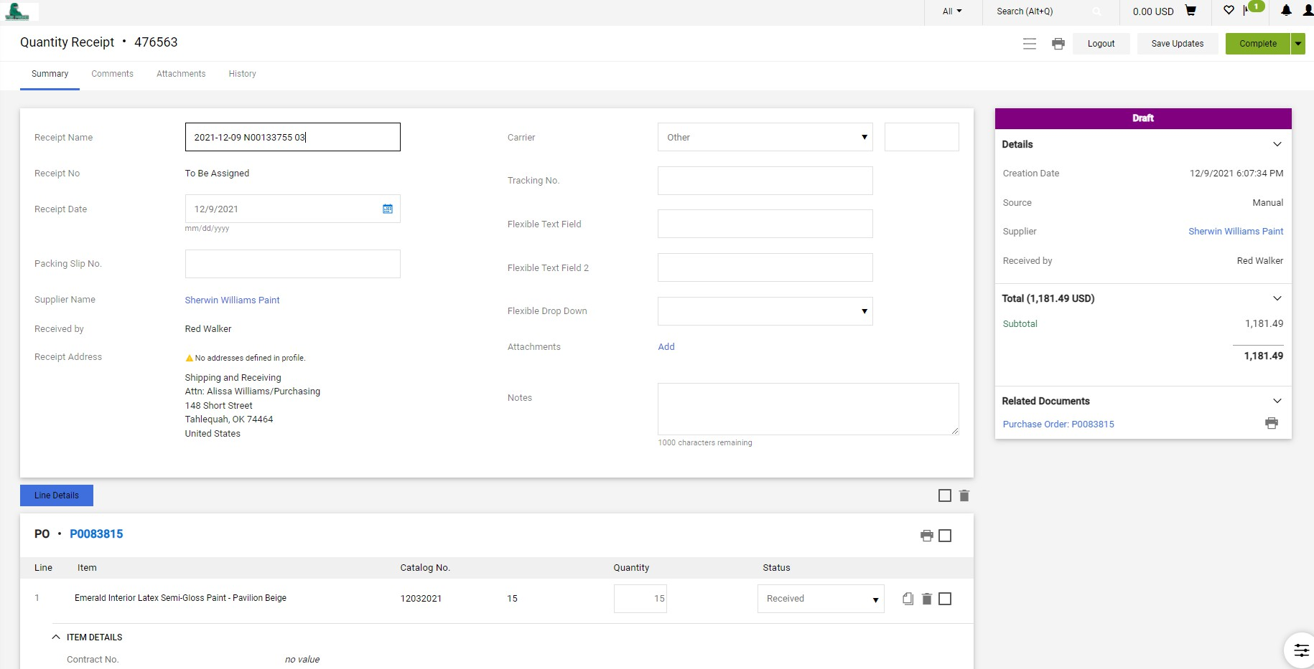

- Scrolling down to the Line Details.
- For each line, select the quantity received and the status. 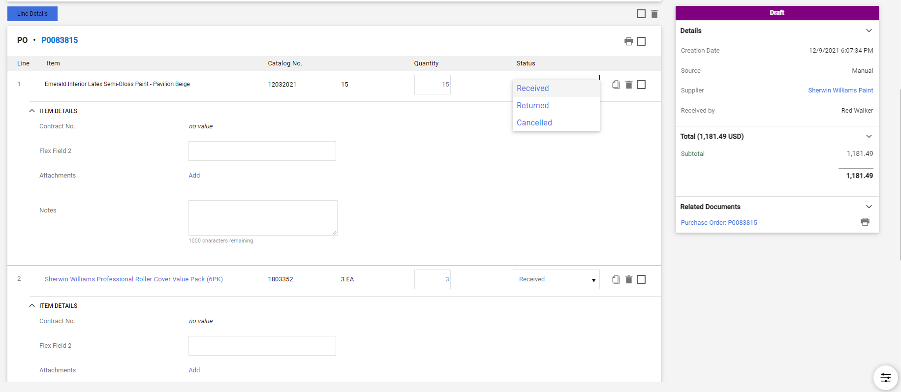

- After ensuring the amounts and status are correct, scroll back to the top of the page and click complete. 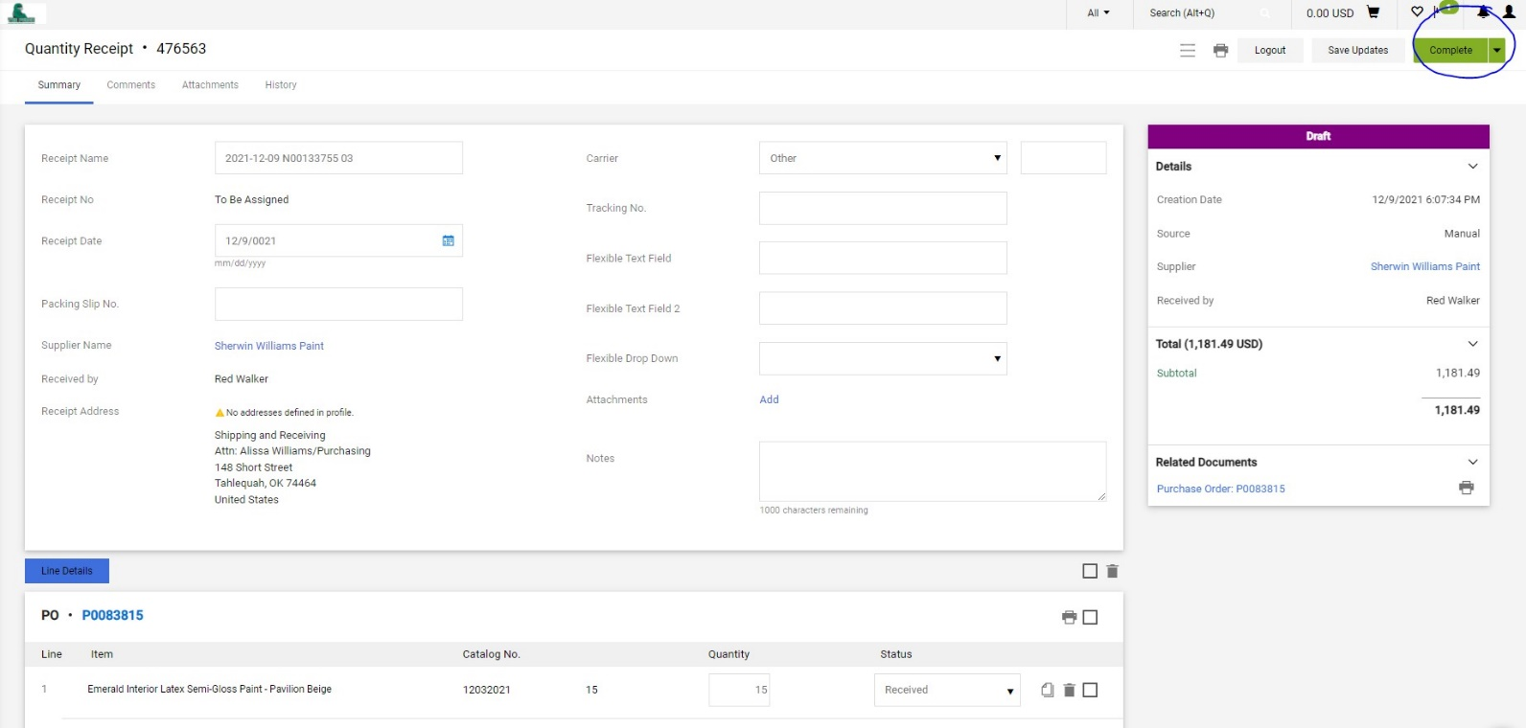

- You will be taken to a screen below where the receiving number can be recorded for you records if necessary. 