Non-Catalog Item

- Select Non-Catalog Item towards the top of the Dashboard.

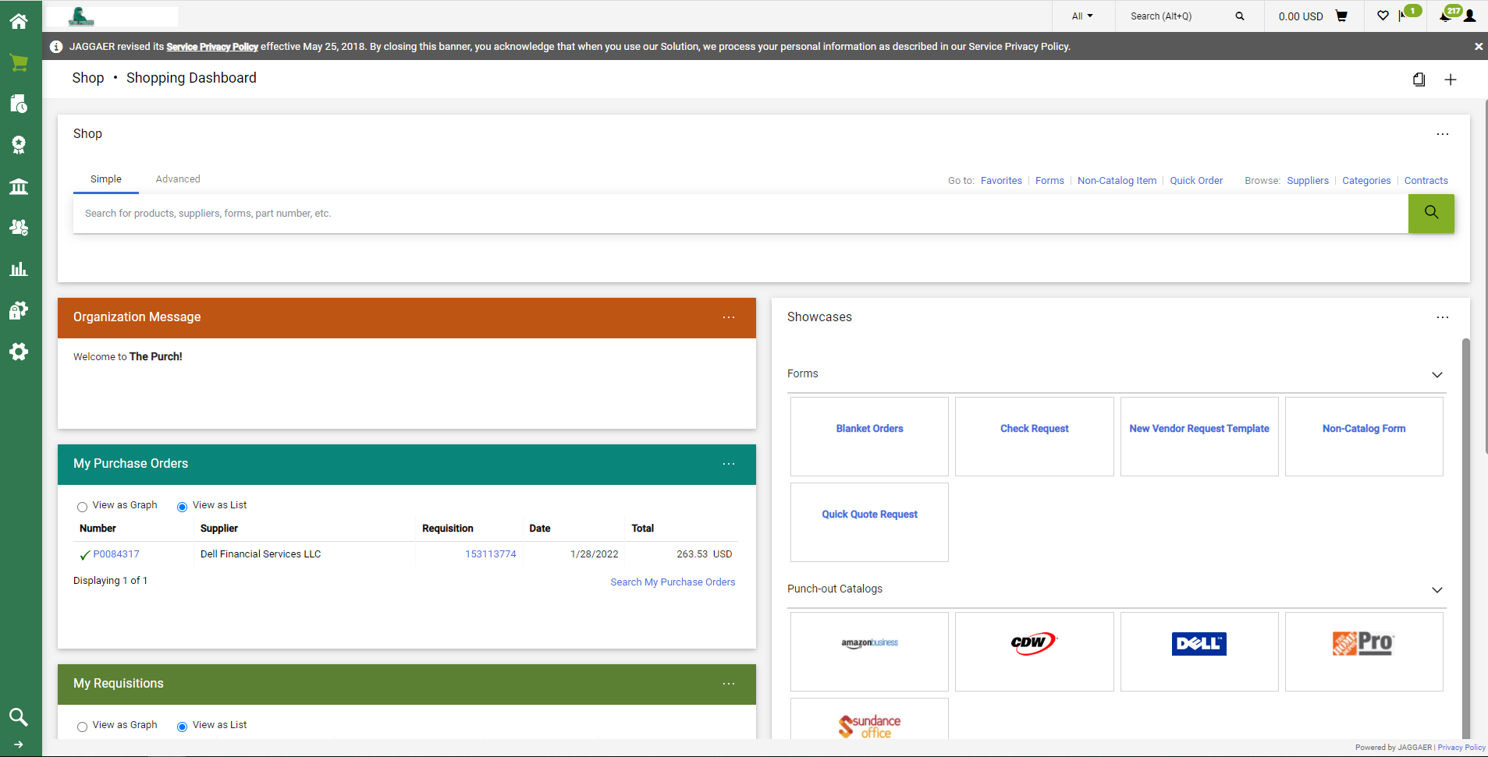

- Start typing In the Vendor/Supplier Name in the Supplier Info Box, then select the correct name from the auto populated names.
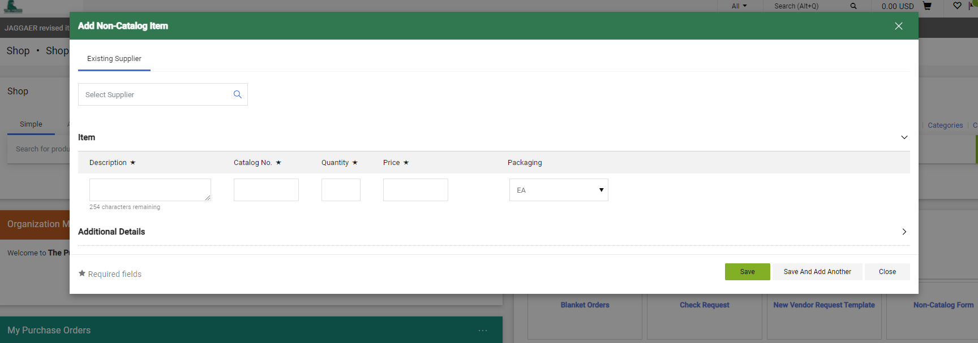
- Select the correct address if multiple addresses are shown.
**If there are not multiple addresses shown, then we only have one address type on file for them.

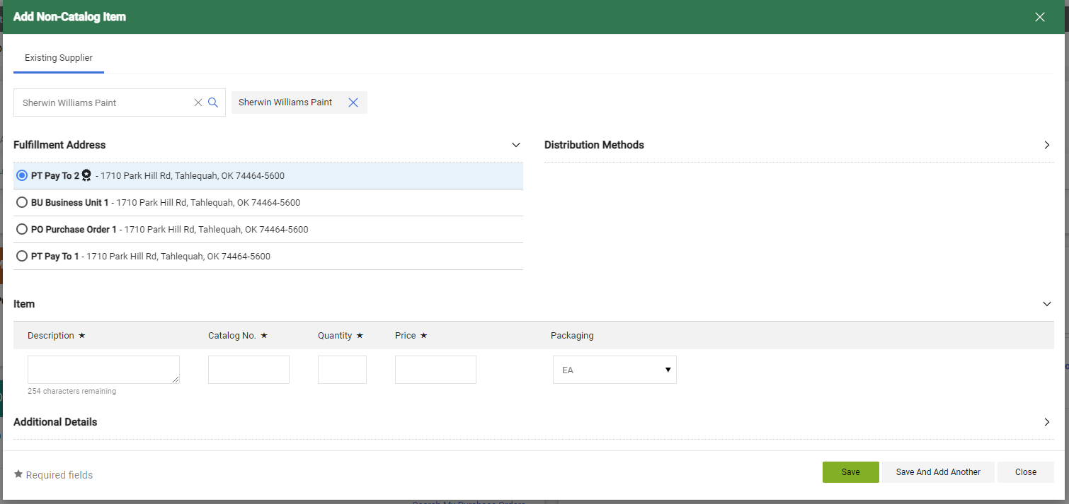

- Enter the description, the catalog number (if none, just enter N/A), the quantity, price, and packaging type (optional).
- If entering multiple line items, click “Save And Add Another” then repeat step #4.
- If no other line items need to be entered, click “Save”

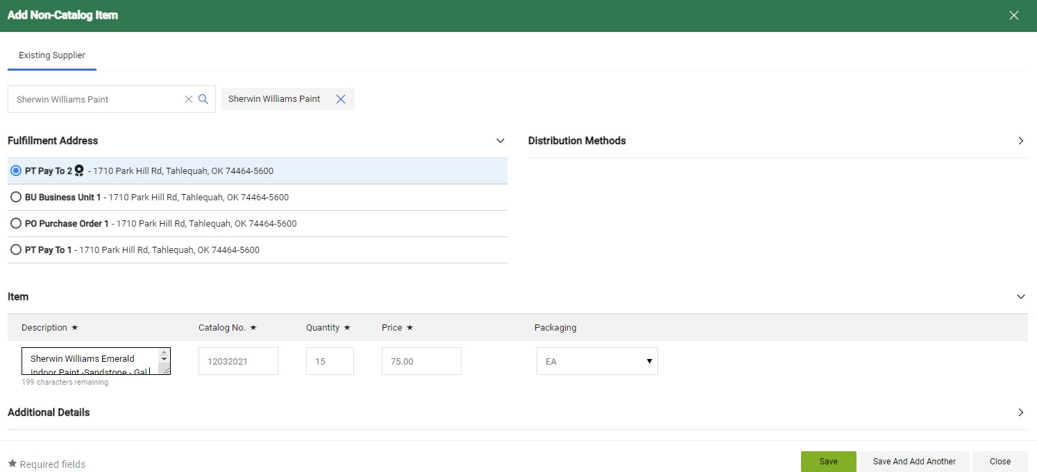
- This will bring you back to the main dashboard. Click on the shopping cart at the top right of screen.

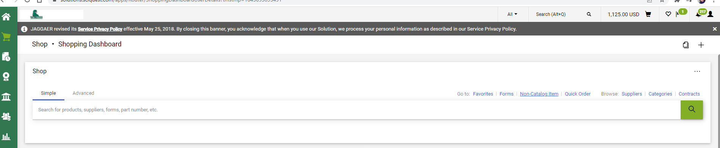

- Click “Checkout”
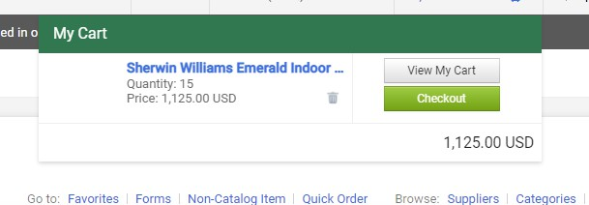

- Click on the pencil icon to edit the shipping address.

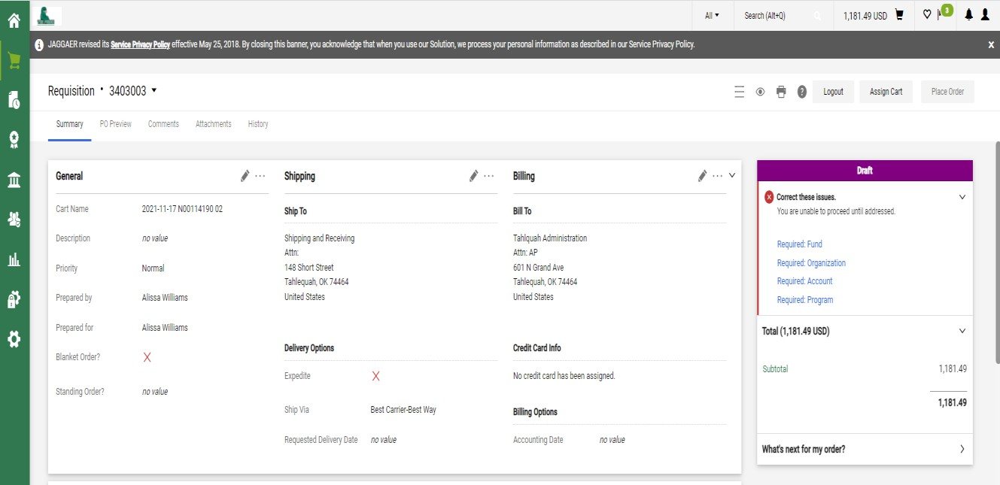
- Select the shipping address and enter your name and/or department in the Attn field.
- Click Save.
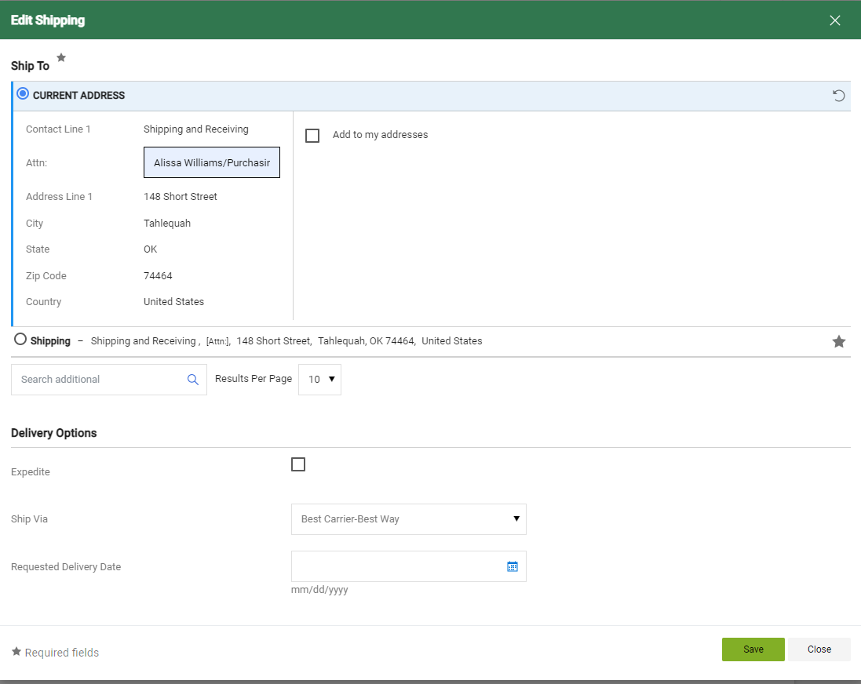

- Click in the pencil icon in the Accounting Code section to enter FOAP information.
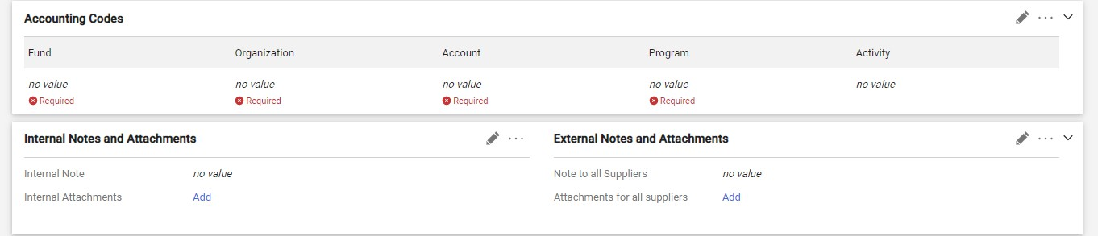
- Type in the Fund, Org, Account, and Program Codes
- Click Save
(*If one or more items have a different account code or need to be coded to a different FOAP, go to next step.)

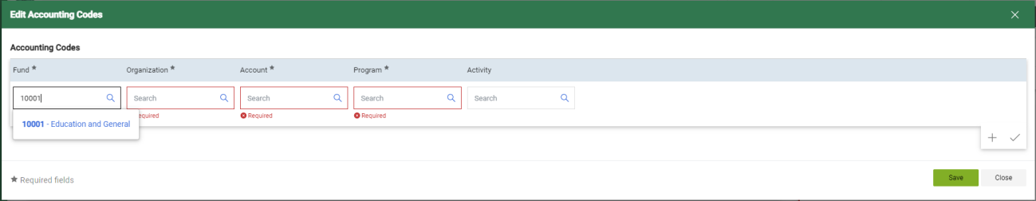

- If another line item has a different FOAP or Account Code, Click the ellipsis on the right side of the line item you are needing to change the FOAP or Account Code.
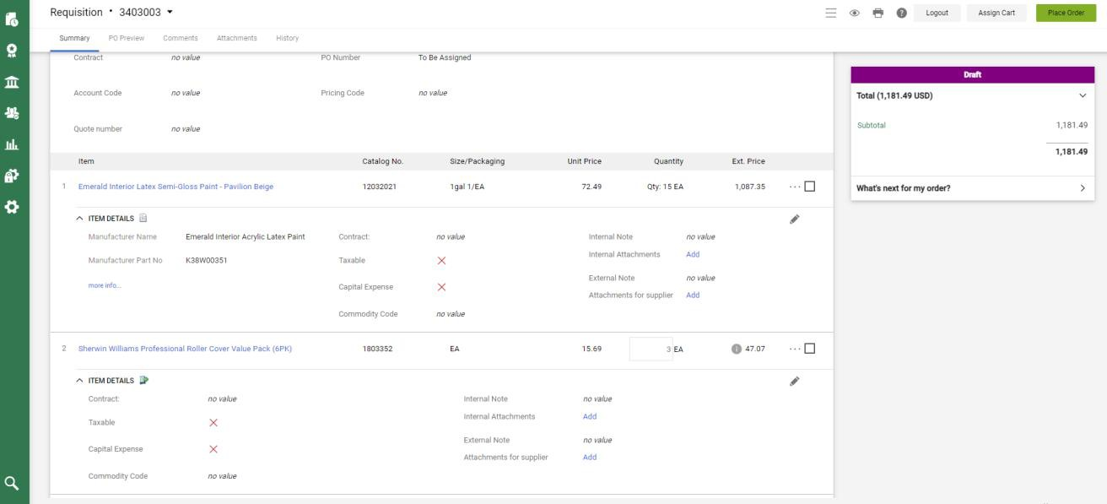
- Snapshot of screen directing user showing the user an example of the above text directions. 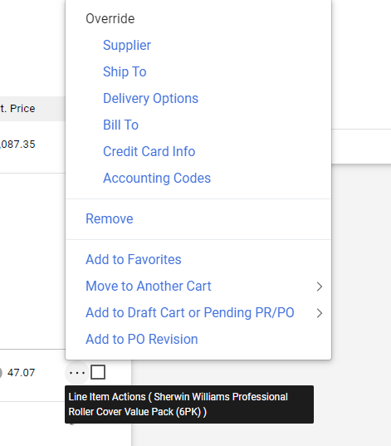Click “Accounting Codes”

- Enter the correct codes that need to be changed
- Click Save
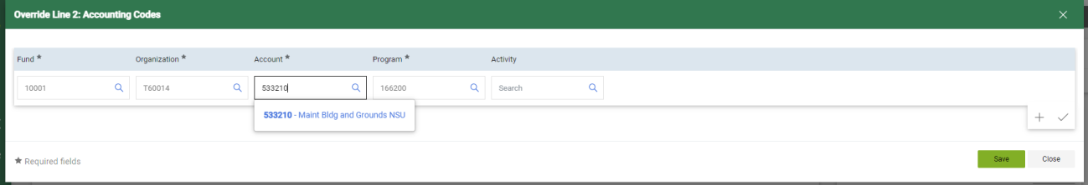
- Add Backup Documentation (Quote, Agreement, Food Form, etc.,) by clicking “Attachments” .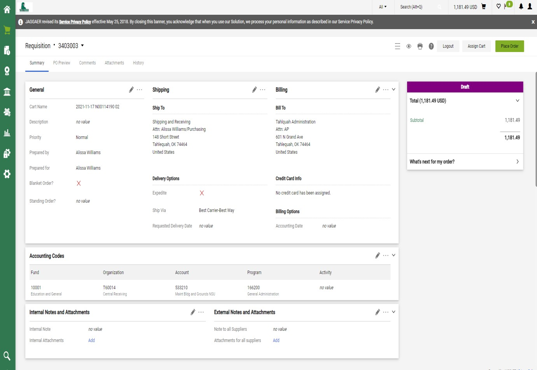

- Click Add Internal Attachment
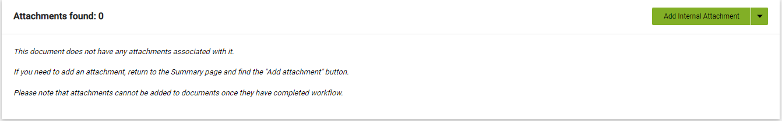

- Click “Select Files” and then choose your file to attached.
- Once file is attached, click on “Save Changes”
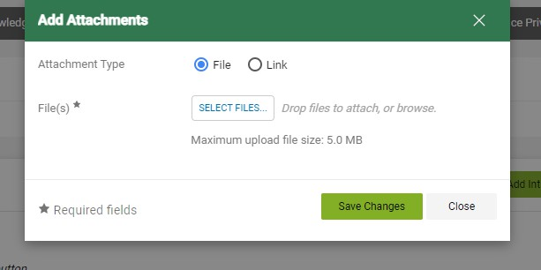
- Click “Place Order”, if no other changes need to be made.


25. The Requisition is now completed and submitted for approvals.
