Punch-Out Catalogs - Amazon

- Log on to The Purch.
- Click on the Amazon tab located in the Punch-Out Catalogue section on the home screen.
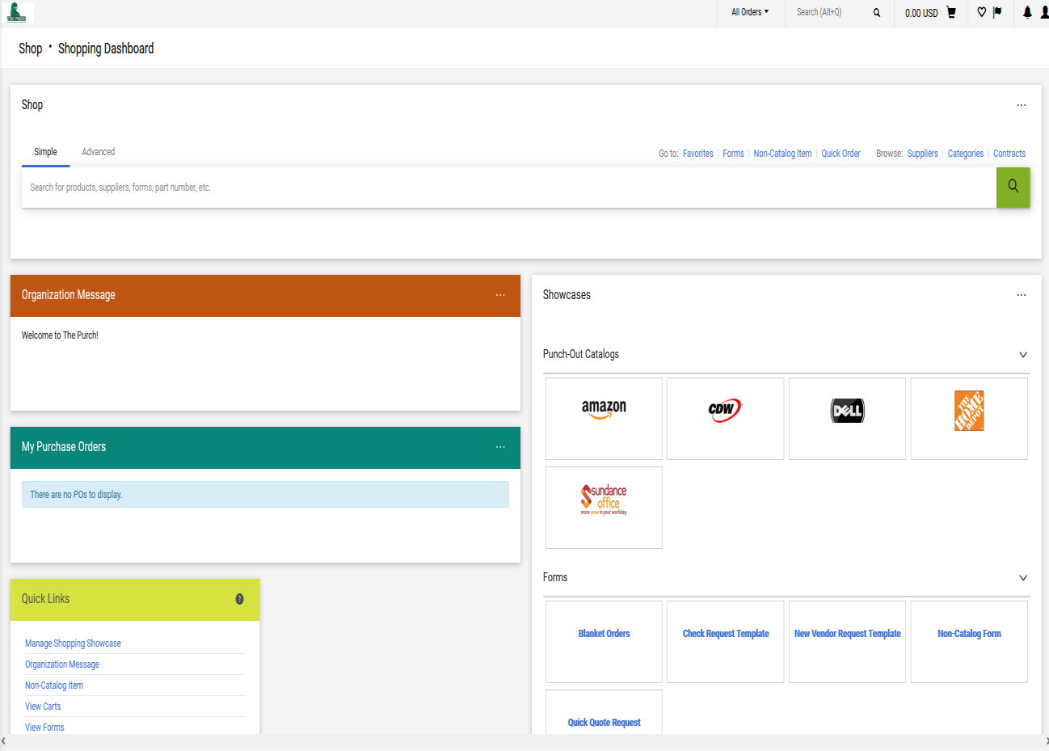

- This will bring you to the Amazon shopping page ad you can begin shopping for items.
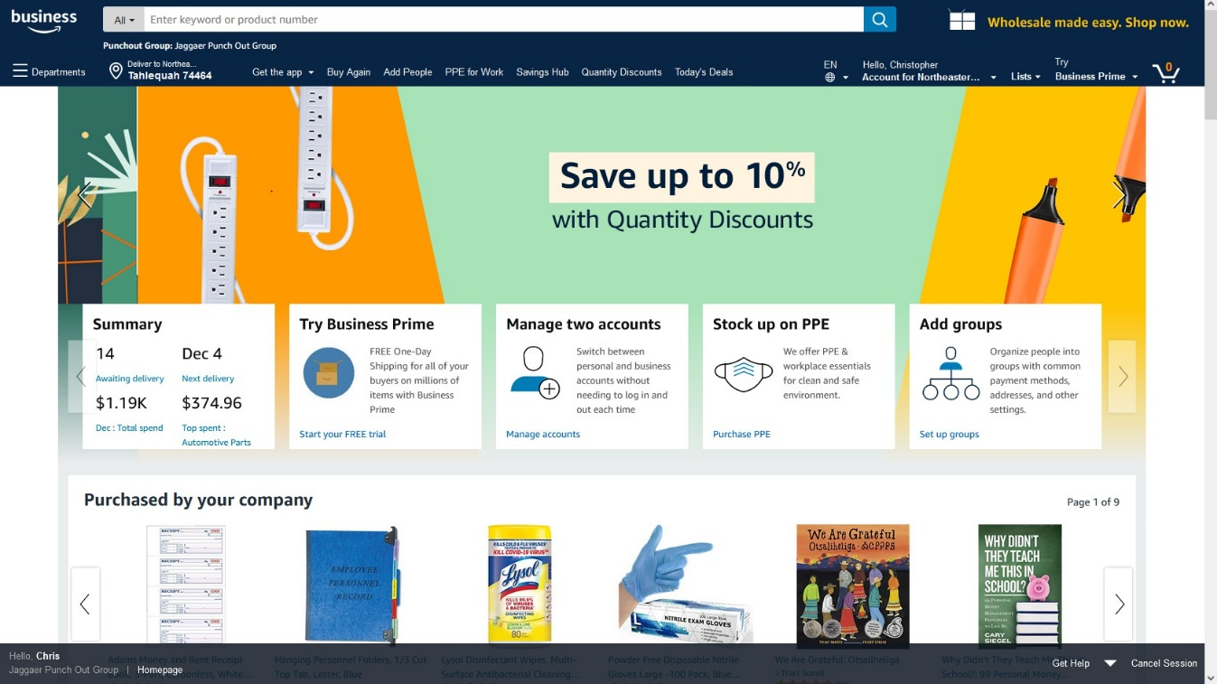

- When you have found the item you wish to purchase, click the “Add to Cart” button.
- Repeat Steps 3 & 4 until all items you wish to order are in your cart.
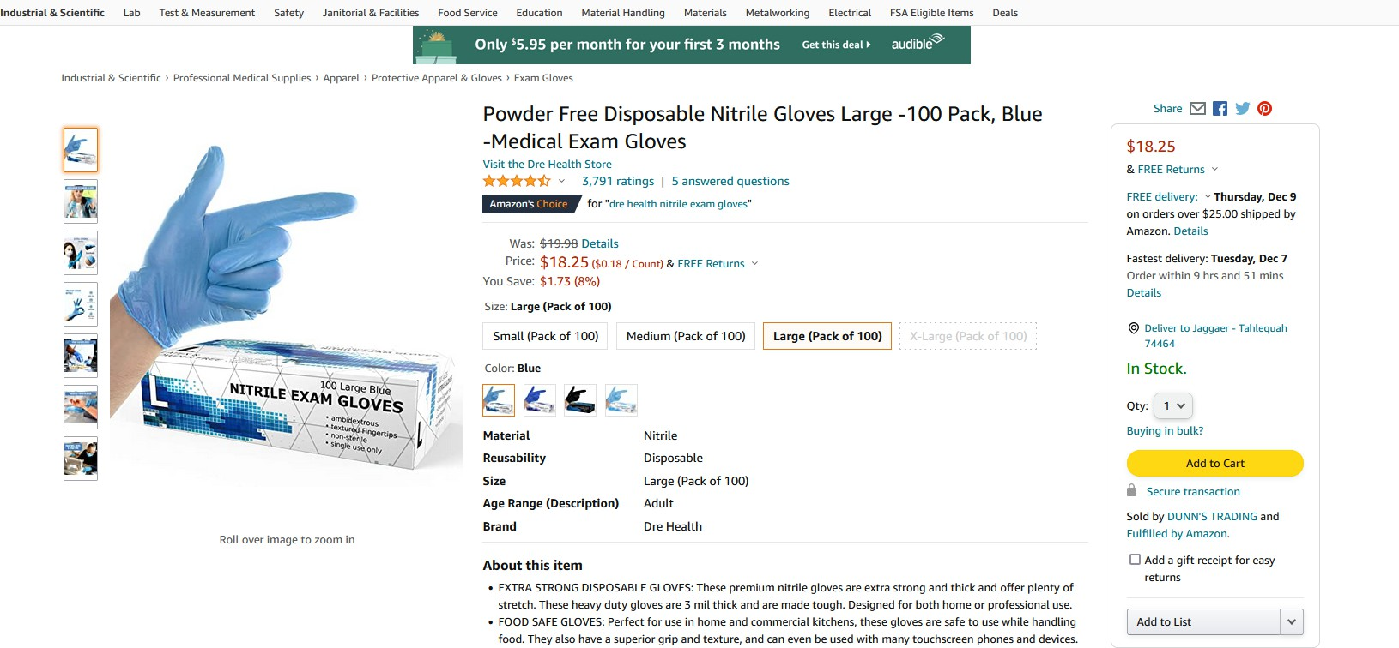

- When you are ready to check out, click on the cart button located at the top right of the screen.
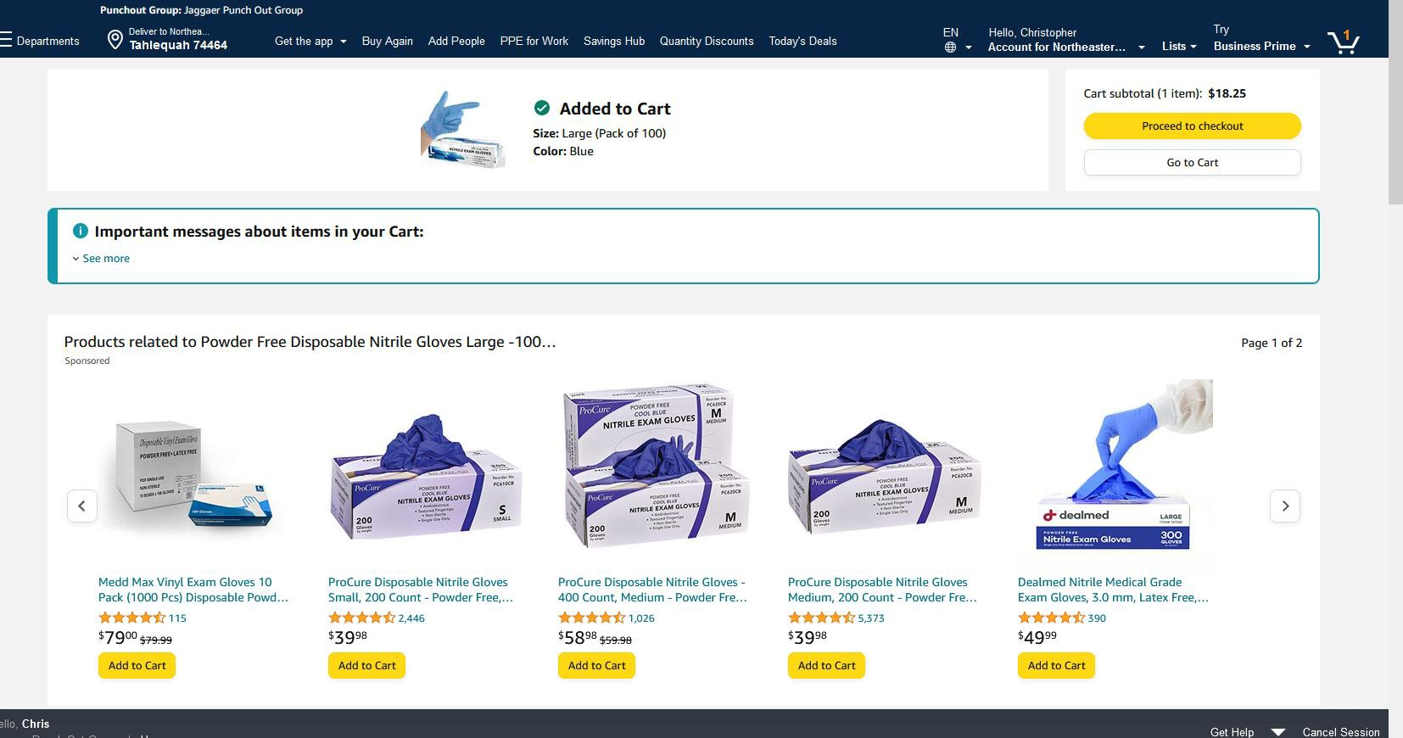
- After Reviewing your order, click “Proceed to Checkout”. 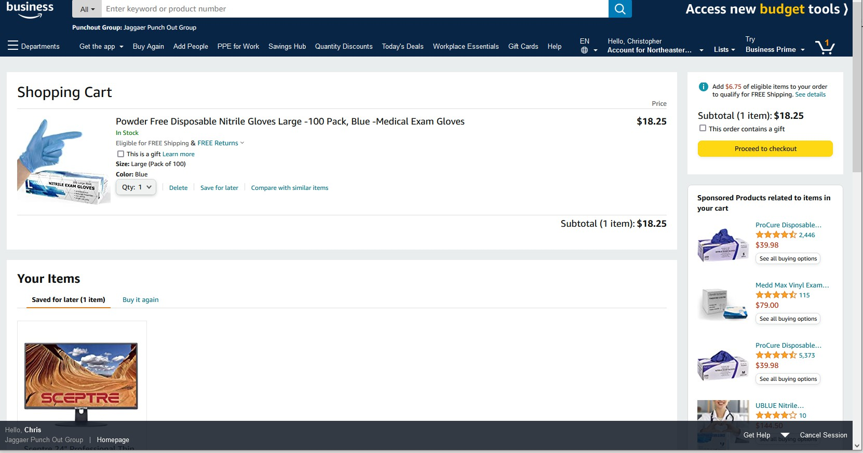

- Amazon will ask which address to deliver to, select the correct address for your campus.
- Click “Deliver to this address”
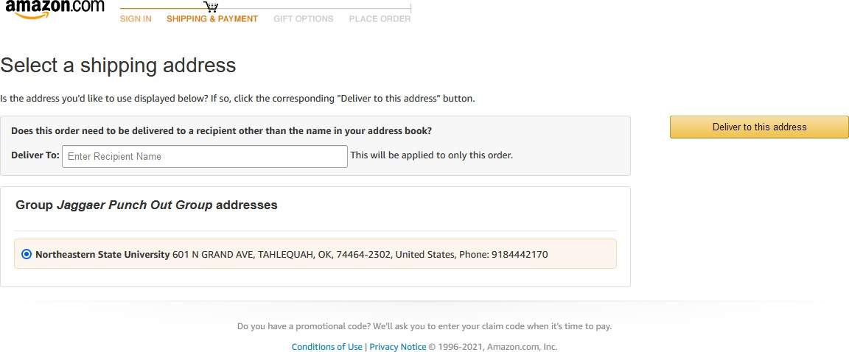

- Choose your shipping options
- Click Continue
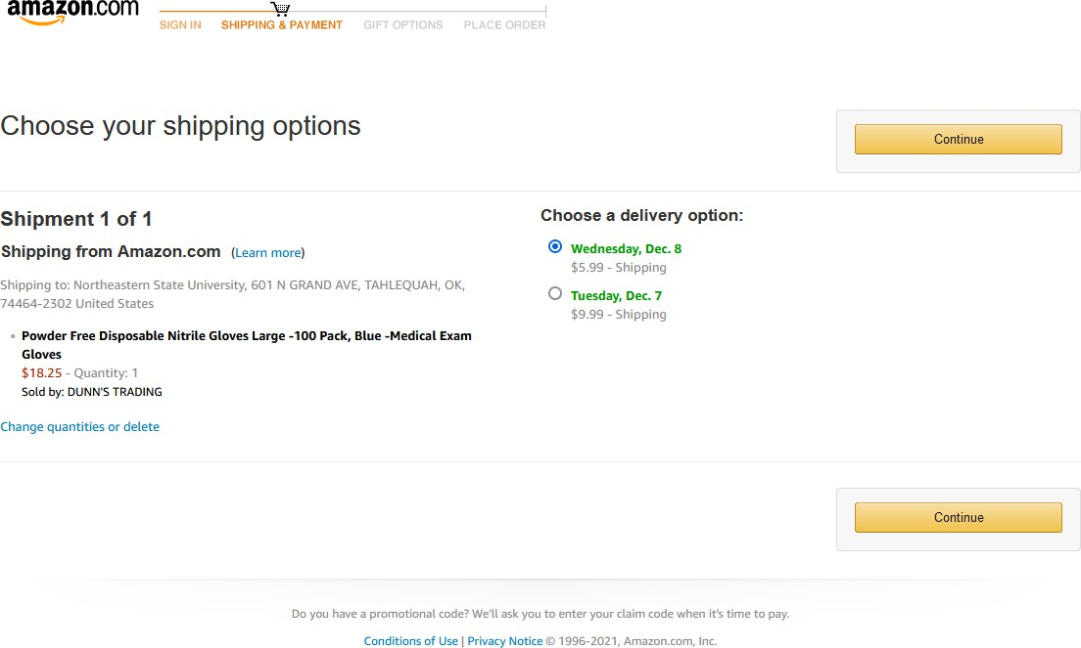

- A payment option will be provided for you….Do NOT Change or Add your pcard number.
- Click “Continue”
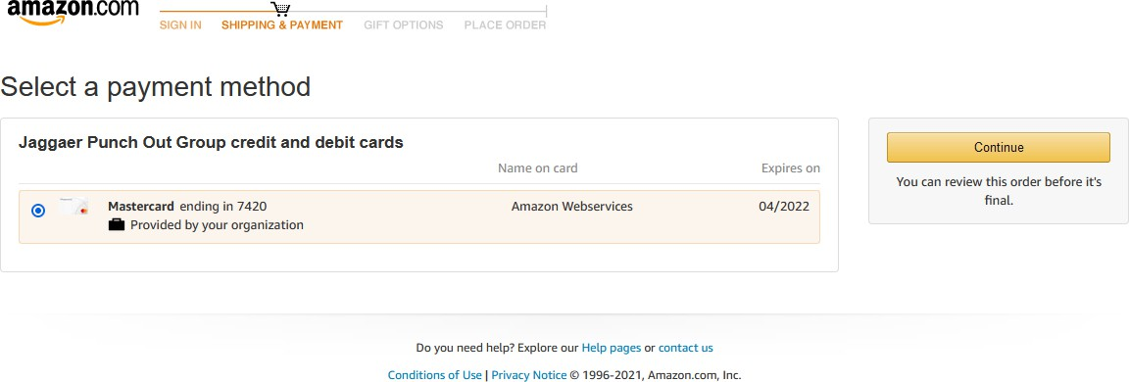

- Click ”Submit Order for Approval”.

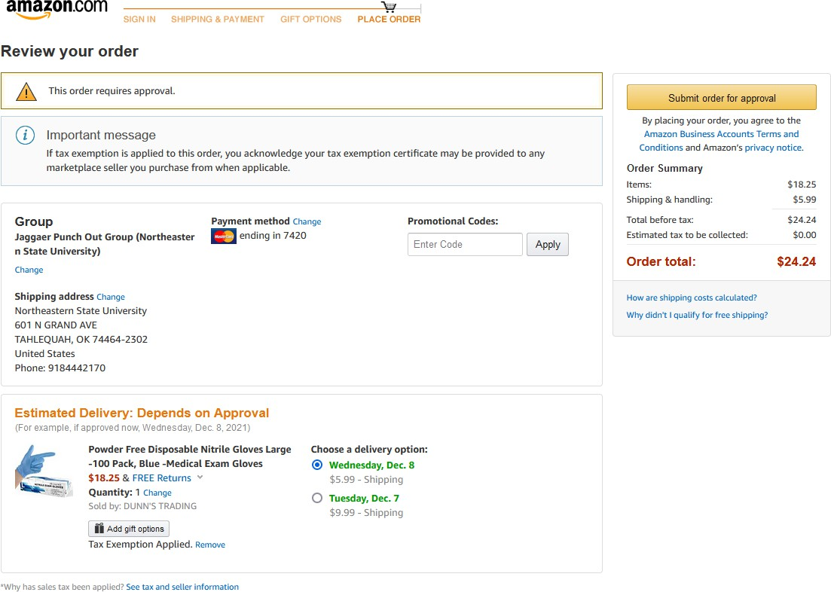

- This will bring you back to The Purch. Review items and click “Proceed to Checkout”.
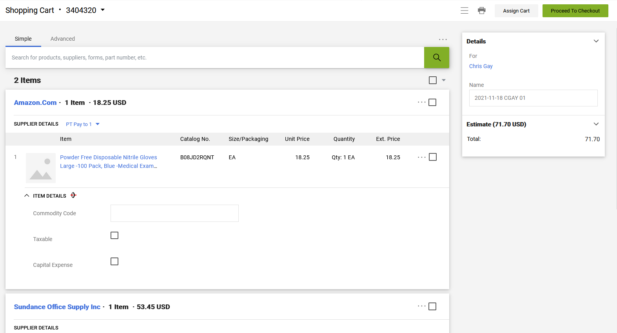

- This will Bring you to the Requisition Screen. Click the Pencil Icon next to Shipping to add shipping address. 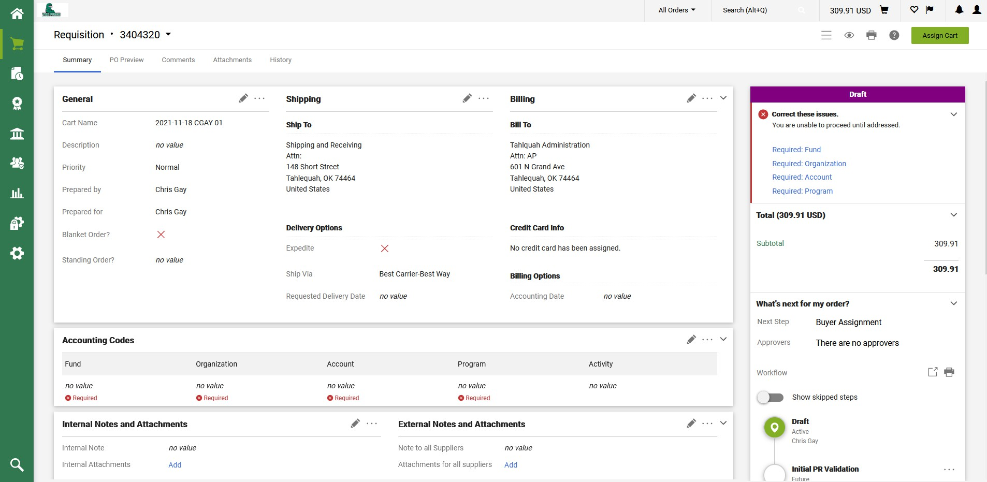

- Select which campus you want the order to be shipped to by typing the Address in the Search box or selecting address already saved in addresses.
- Type name or department name in Attn box.
- Click Save.
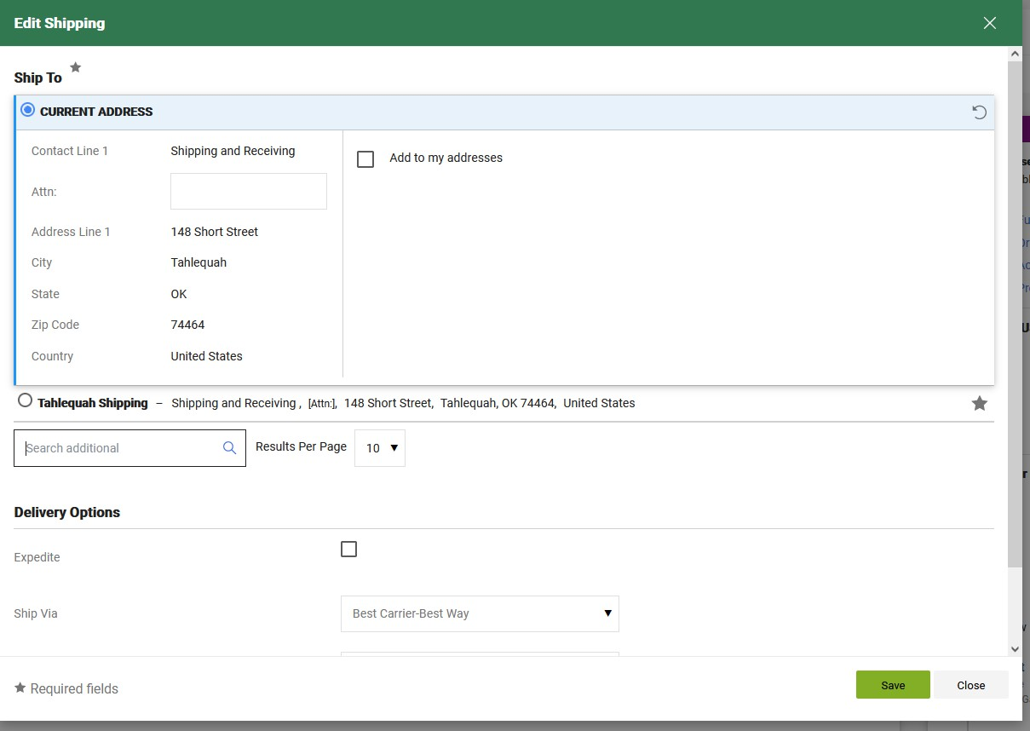
- Next add the FOAP by clicking on the Pencil Icon in the “Accounting Codes” section

- Enter in FOAP information
- Click Save.
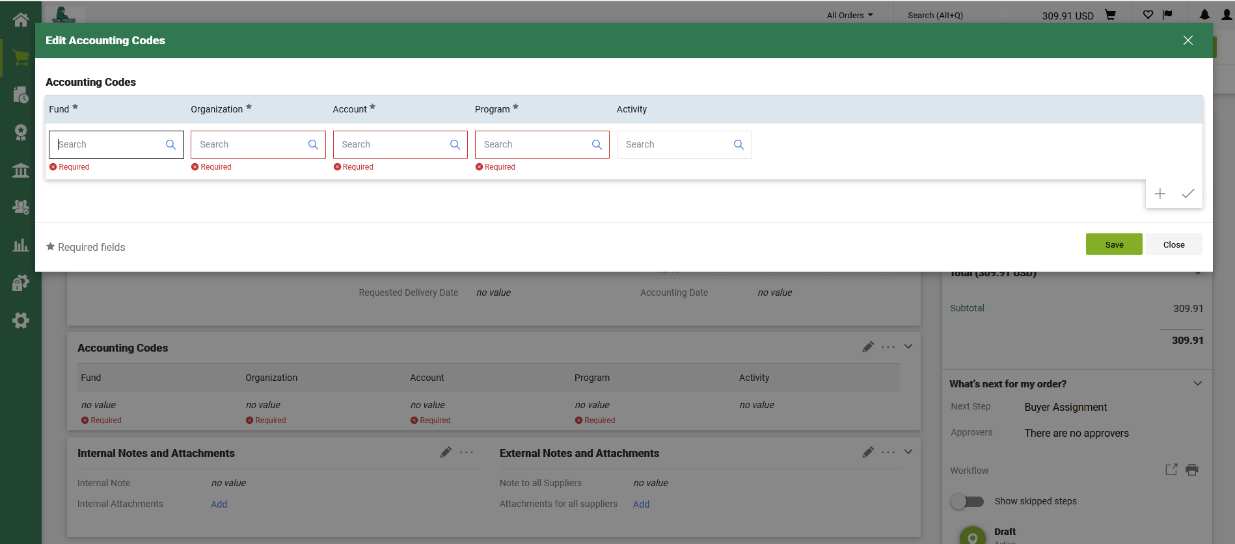
- Review that all items are correct and then click “Place Order”
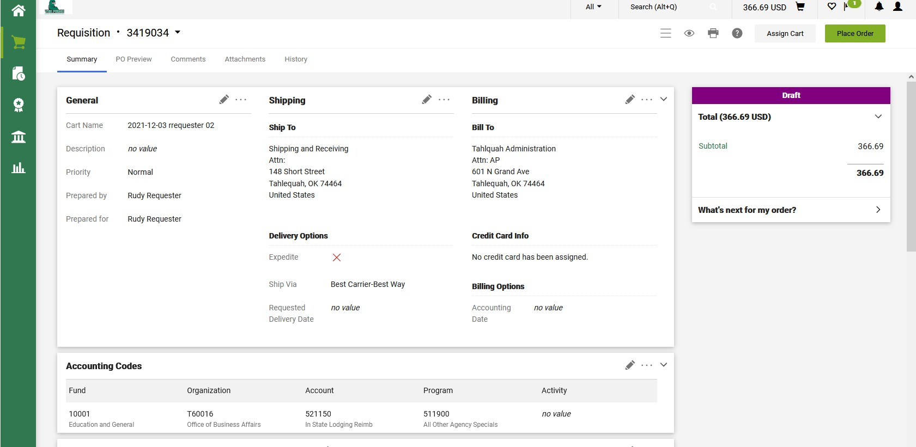

- Your order is now submitted for account sponsor approval. 