Punch-Out Catalogs - CDW

- Log on to The Purch.
- Click on the CDW tab located in the Punch-Out Catalogue section on the home Screen.
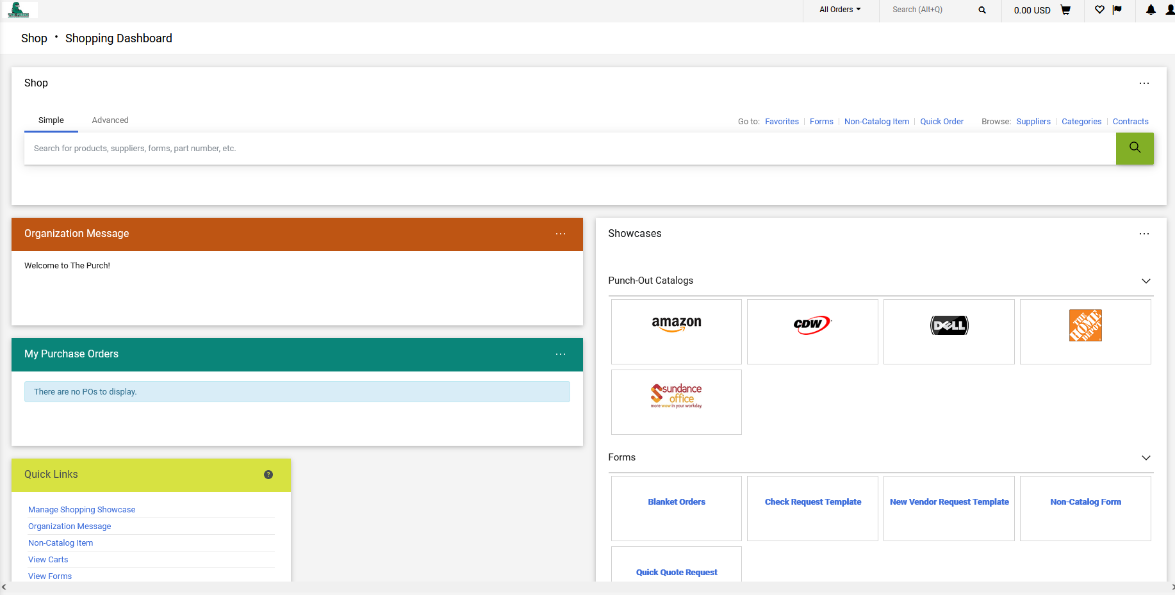

- This will bring you to the Dell shopping page.
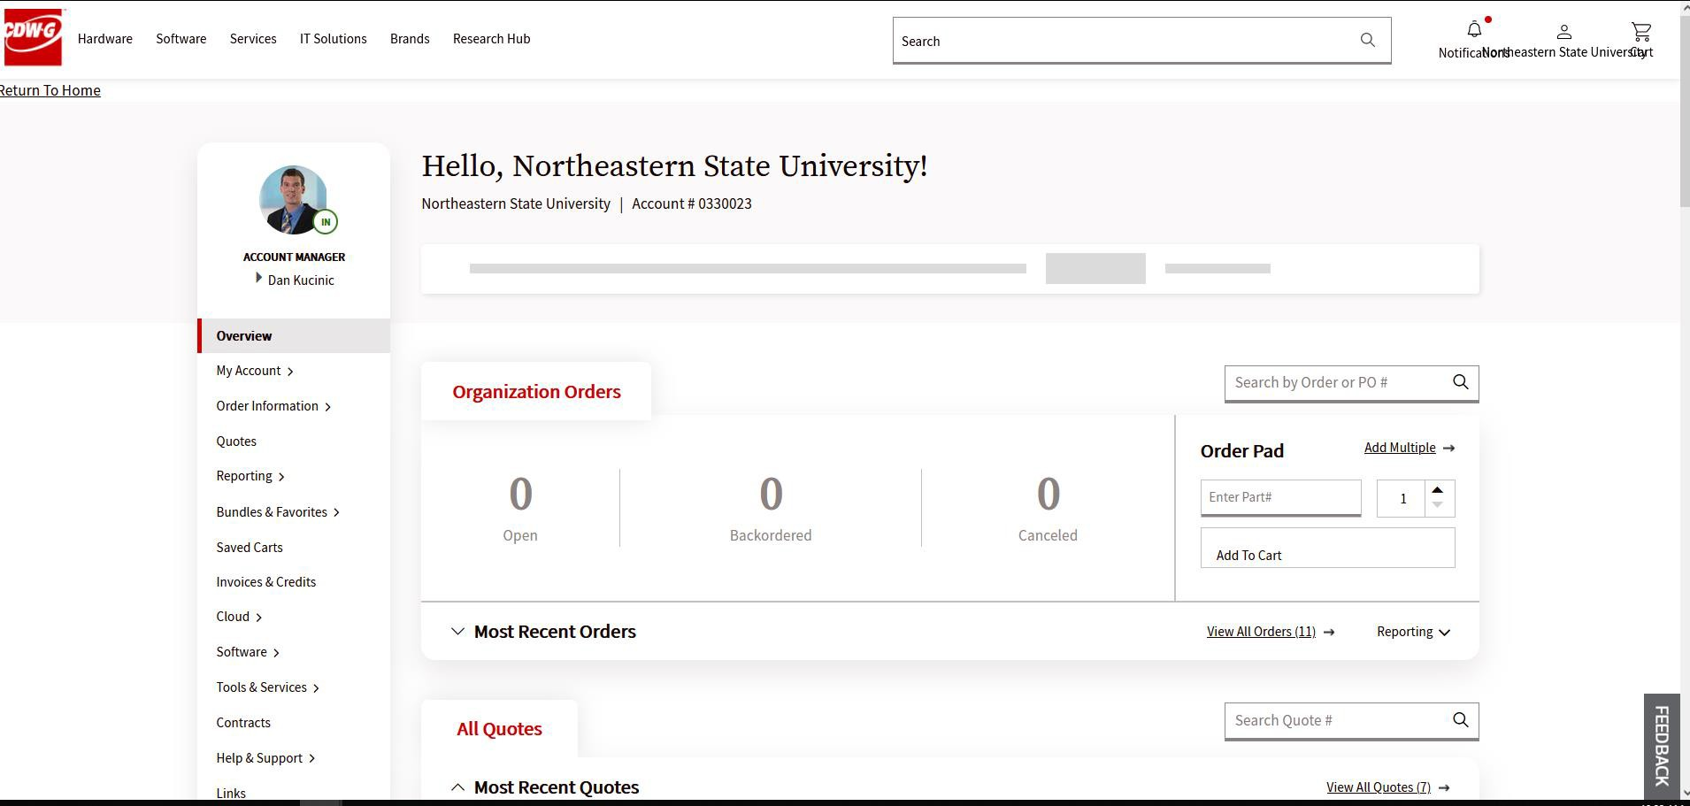
- Search and shop for the items you are wanting to purchase.
- When you have found the item you wish to purchase, click the “Add to Cart” button. 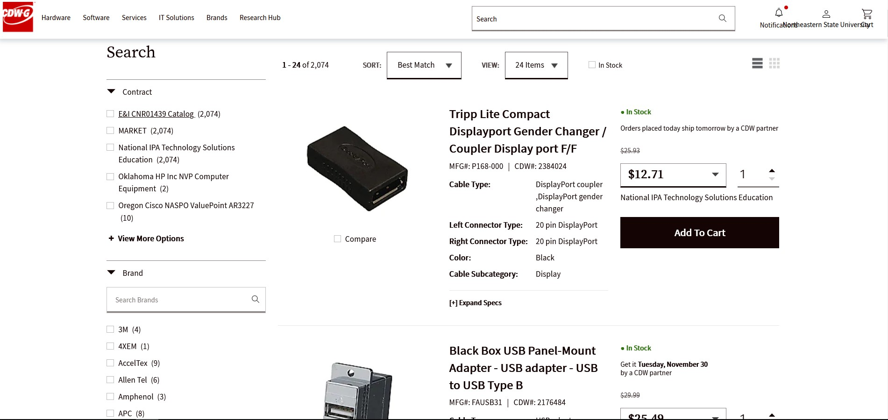

- When you are ready to check out click on the cart button located at the top right of the Screen.
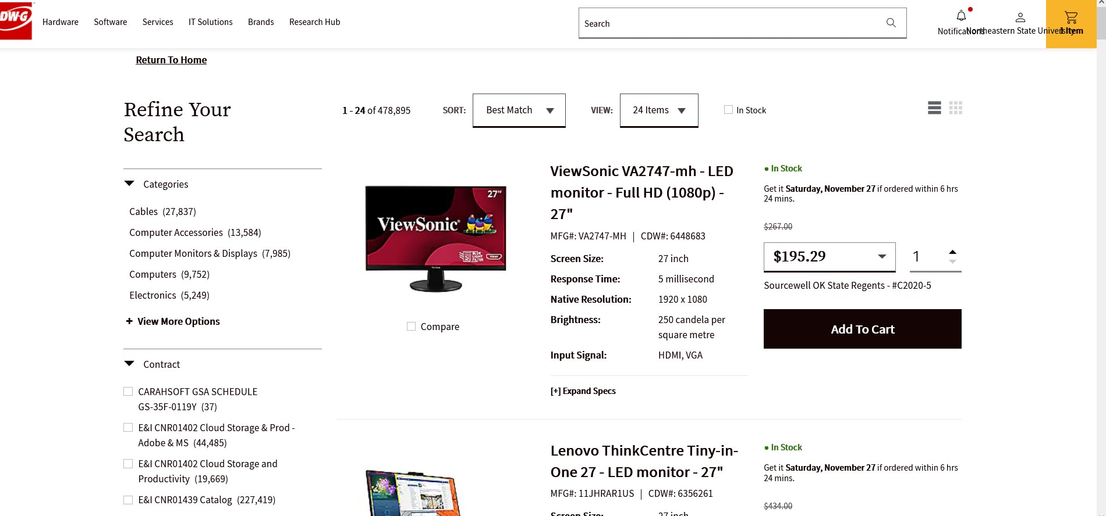
- After Reviewing your order to make sure it is correct select the Checkout Button to continue. 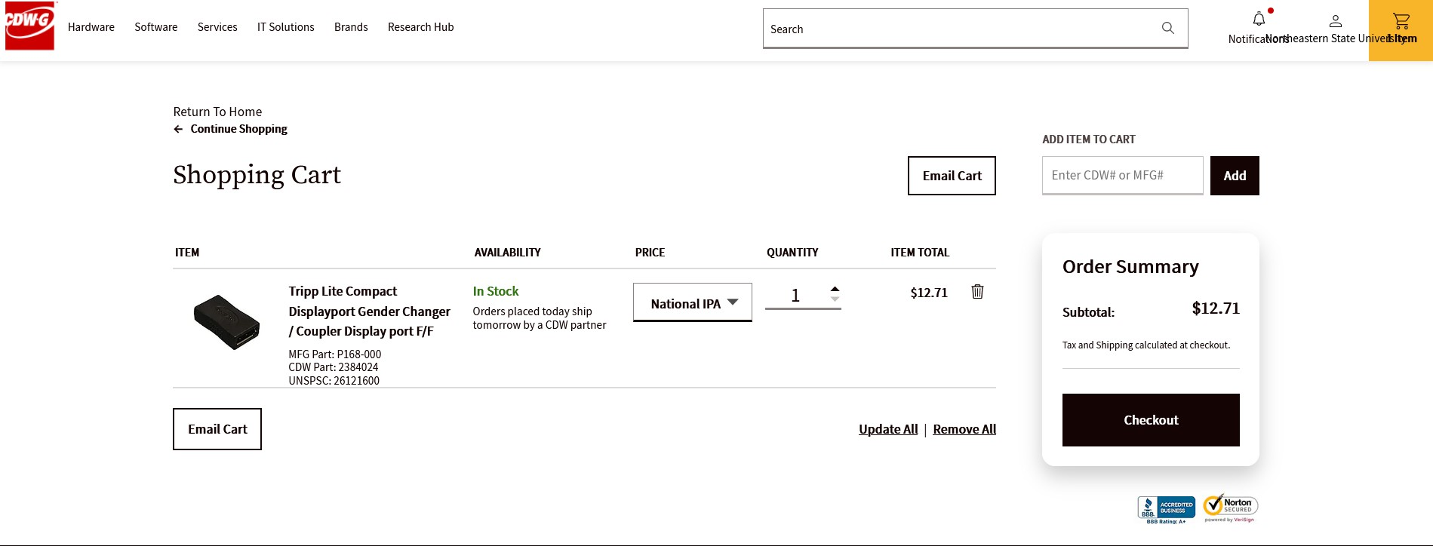

- Press the Transfer shopping cart button to continue.
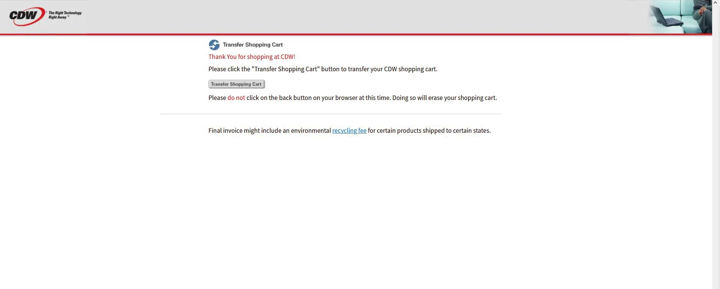
- This will bring you back to The Purch. From here you will click on the proceed to checkout located in the top left of the screen. 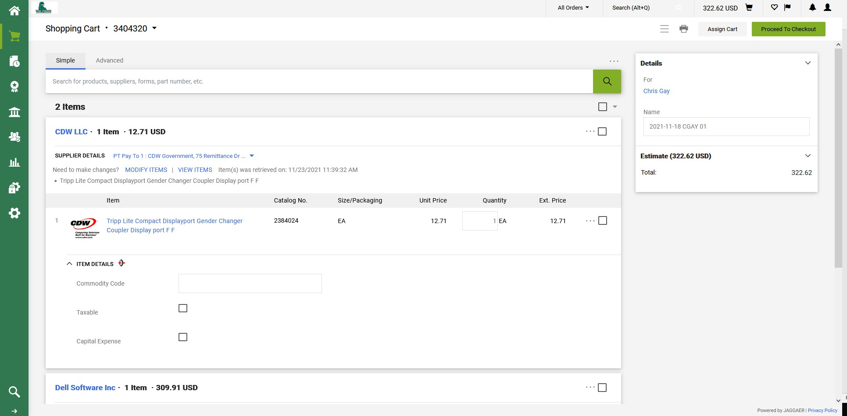

- This will Bring you to the Requisition Screen.
- From here you will be entering Address for order to be shipped, by clicking the Pencil icon next to shipping.
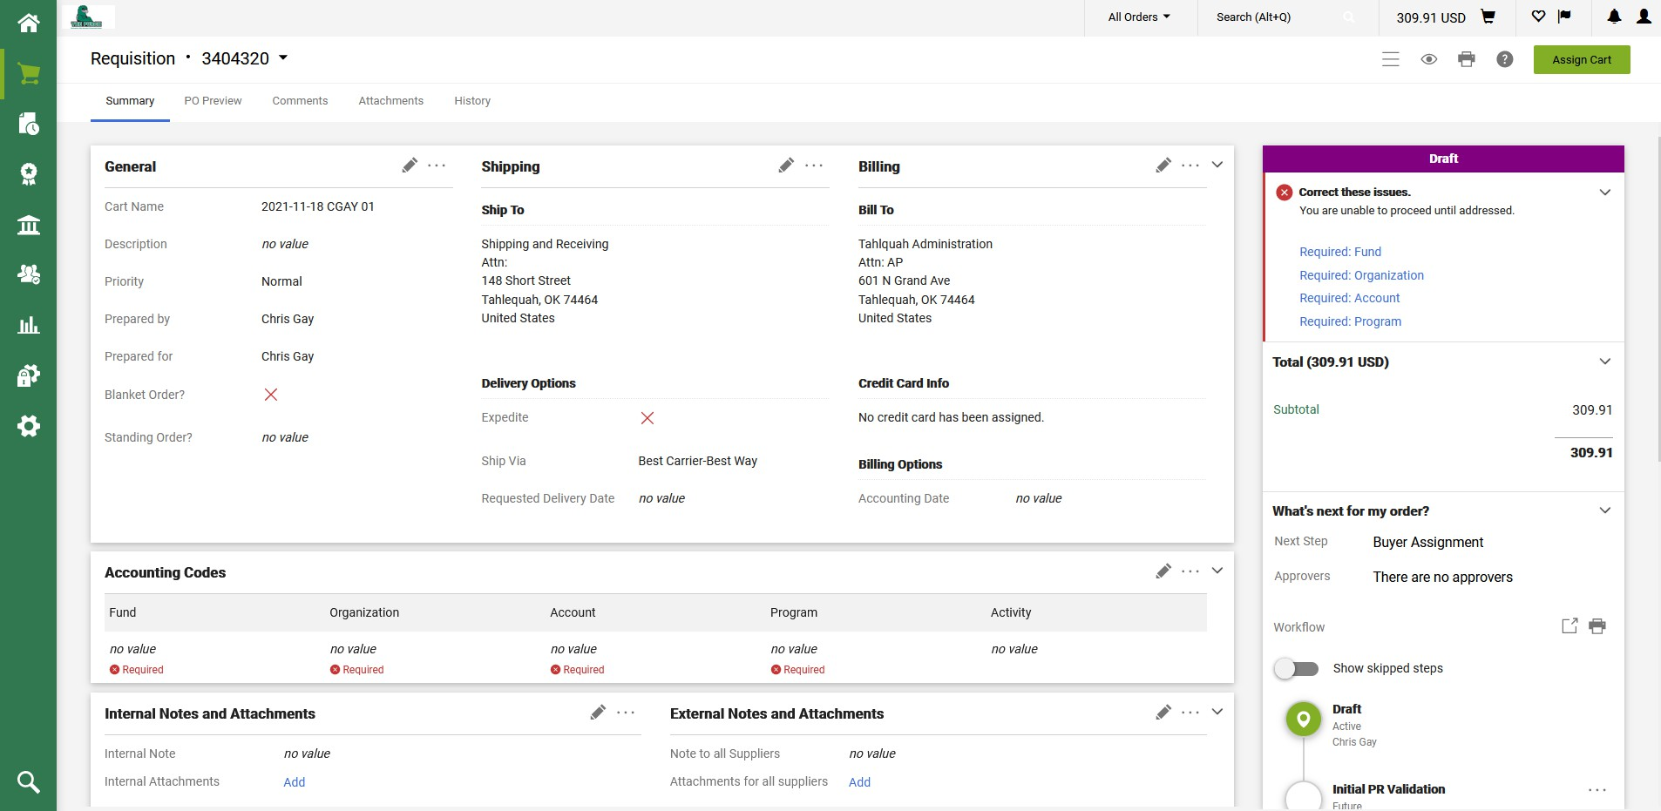
- This will open the Shipping menu. From here you can select which campus you want the order to be shipped to by typing the Address in the Search box. For this example, we will be using the Tahlequah shipping and receiving address.
After you have selected the address click the save button to continue.
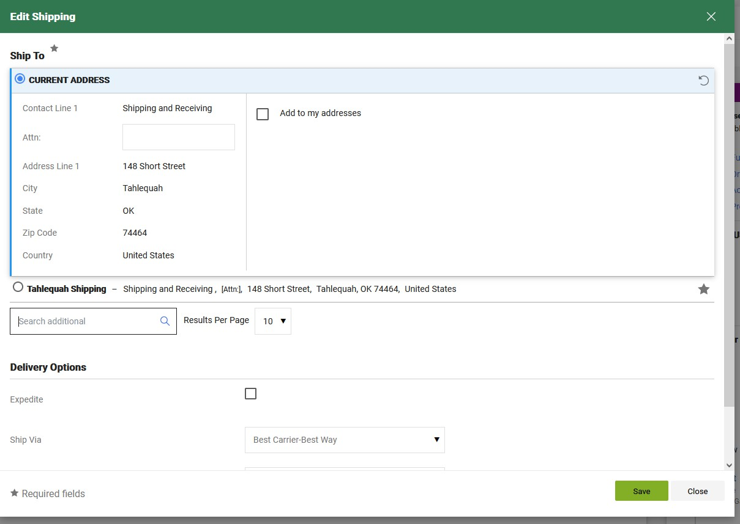

- Next, we will add the account code. You can click on the pencil icon in the accounting section to add the FOAP.

- Here you can add your Fund, Org, Account, Program and activity code once you have done this click the save button to continue.
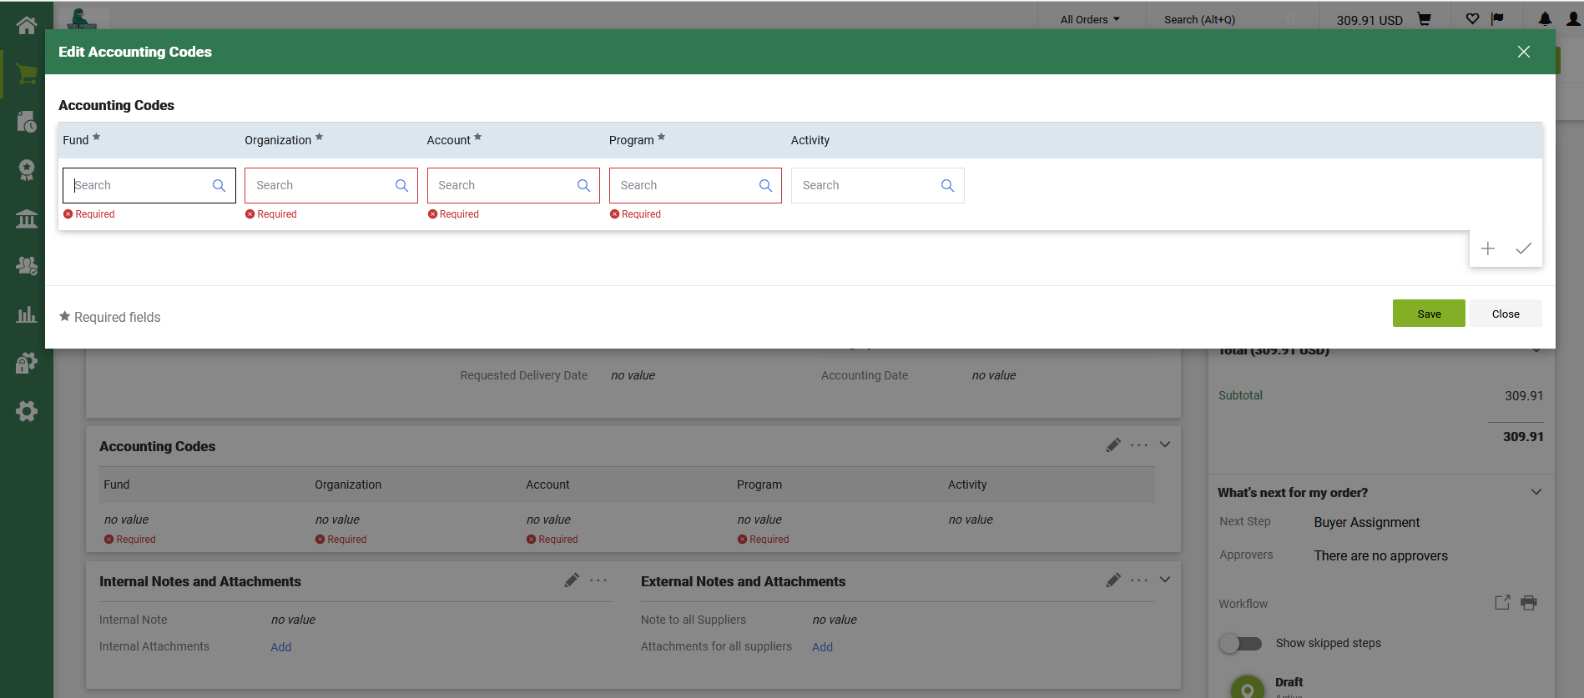
- After you have double checked that the information you have entered is correct, you will click the place order button. 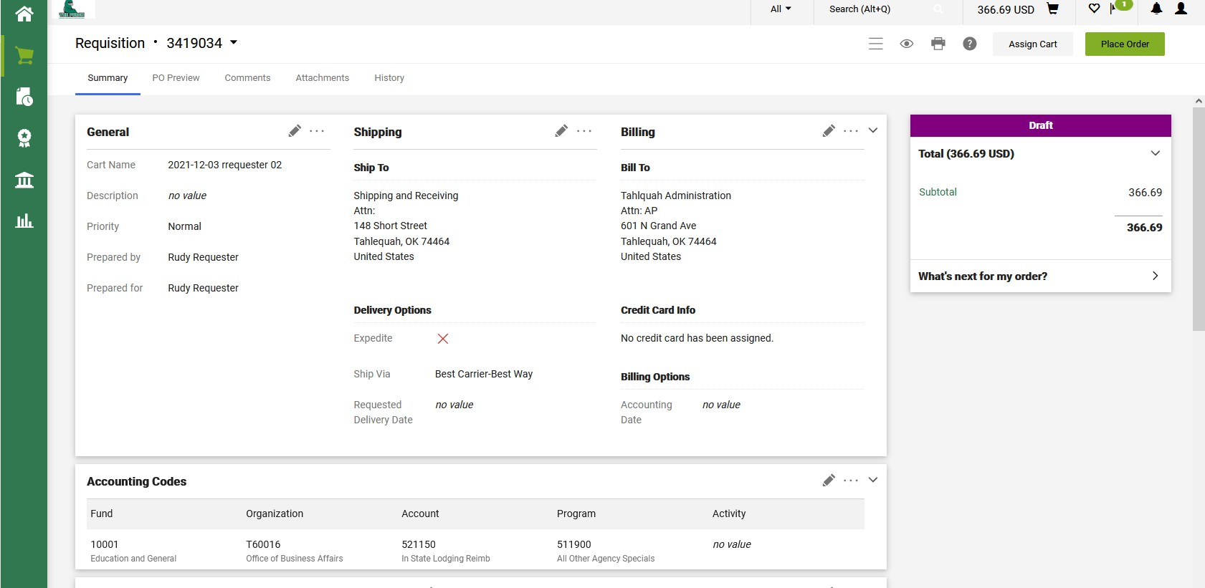

- Your order is now on its way to be approved by your account supervisor and to be the purchasing office to be made into a PO. 