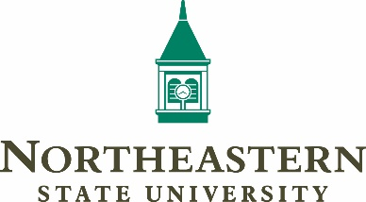
Photo & Video Release Form (Mixed Audience)
I understand this is a standard Northeastern State University form that gives the University permission to use photographs, video clips, other images, etc. from university activities and events, including testimonials, commercial shoots, research day events, awards programs, etc. Said use includes but is not limited to the University’s web sites, social media presence, promotional brochures, newsletters, postcards, etc. including any and all publicity materials, current and future.
For consideration received, I hereby grant to Northeastern State University, their successors and assigns, and those acting under their permission, or upon their authority, or those by whom they are commissioned:
- The unqualified right and permission to reproduce, copyright, publish, circulate and otherwise use photographs and/or video tapes of me, whether taken in a studio or elsewhere, in black-and-white or in colors, alone or in conjunction with other persons. I hereby waive the opportunity or right to inspect or approve the finished photographs or video footage or the use to which it may be put or the copy or illustrations used in connection therewith.

- All my right, title and interest in and to all negatives, prints, tapes, and reproductions thereof, and I do hereby release the aforesaid parties and their successors and assigns, if any, from any and all rights, claims, demands, actions or suits which I may or can have against them on account of the use of publication of said photographs and/or motion pictures or tapes. I have read and understood the release stated above and do hereby agree to its terms and conditions.

Signature_________________________________________________________ Date _______________
Print Name: _____________________________ NSU ID # (if applicable)___________________________
University & Major:_____________________________ Email: __________________________________
Start date (Semester & Year): ______________________ Anticipated Year of Graduation: ____________
Phone number: __________________ Hometown (if different from below below): __________________
Address: _____________________________________________________________________________
City: __________________________ State/Country ______________________ Zip: ________________
Please return a copy to:
NSU Communications & Marketing | Journalism 212 | cmprojects@nsuok.edu

