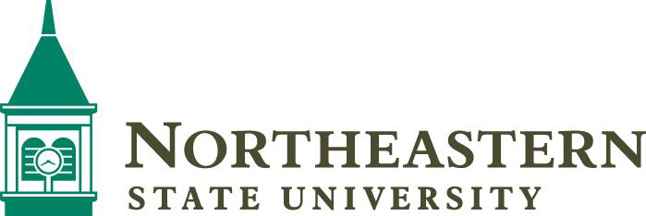

# Expressive Speech Annual Report

December 31, 2020

Pursuant to 70 O.S. §2120, Northeastern State University submits the following to demonstrate its course of action for compliance with the requirements of this statute.

## Campus Expression Policy

The Northeastern State University’s freedom of speech policy can be found here: [Northeastern State University Freedom of Speech Policy](https://policies.nsuok.edu/GeneralCounsel/FreedomofSpeech(ExpressiveActivities).aspx)

## Professional Development for Students and Employees

Northeastern State University communicates policy and expectations to students and employees through educational programming provided to the faculty, staff, and students, as well as publication of policies in their respective handbooks and on the university’s website. The university may also choose to communicate new policy and/or updates through electronic communication. Professional development materials include a summary sheet of general education points and an information postcard for the campus community and the public.

### Copy of Professional Development Training Information Sheet

The following professional development information was provided to the campus community via meetings with faculty, staff, and students. The information is also located in the University Center, Office of Auxiliary Services.

### Copy of Visitor Information Card

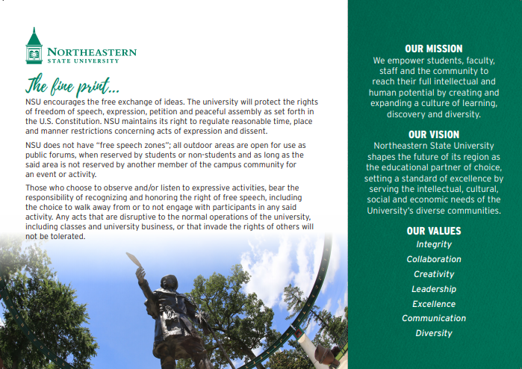

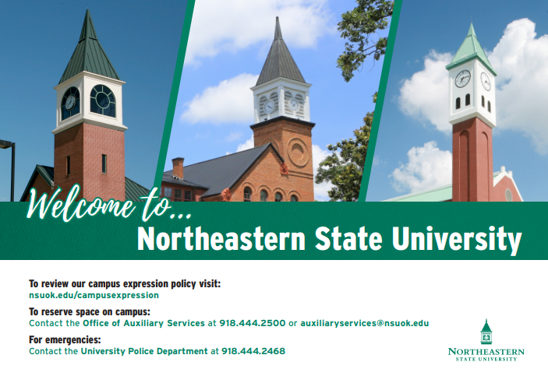

## Barriers or Disruptions of Free Expression

Northeastern State University experienced no barriers or disruptions of free speech during the calendar year ending December 31, 2020.

This report can be found at [Expressive Activities Annual Report for Free Expression 2020](http://a.cms.omniupdate.com/11/#oucampus/nsuok/offices/previewedit/%2Fstudentaffairs%2Fcompliance%2Fexpressiveactivities.pcf).